**CHAPTER 1**

**WSN BASED MOBILE AND PC CONTROL ROOM ENVIRONMENT FOR INDUSTRIAL APPLICATIONS**

**1.1 Introduction**

The use robotics is increasing day by day to replace the manpower for many reasons and uses with high navigational intelligence.

The aim of the development of modern robot control systems at the Institute of Robotics Research is to provide higher flexibility and autonomy for robot systems, together with consistent and user-transparent concepts for installation, programming and operation of robots in their working environment. An important feature of a flexible future-oriented robot controller is the capability to incorporate information from different classes of sensors and to have standardized communication interfaces with other factory-automation components.

In recent years there is a vast technology improvements in industrial control rooms for monitoring the entire field of Industrial plants. High end PLC’s are being implemented for controlling the entire process of fields. But a problem is that even though automation takes the complete control of total plants few authentication and manual actions are needed from user side for completing the control action. Hence there is a must situation for users presence at all times in the control room for taking some timely needed control actions. Due to the static nature of control room environment, the user should always be static to monitor the process.

Data logging is a process in which a computer/controller is used to collect the process control parameters with the help of sensors and analyze and store the results for further future analysis. Scada system is a high end current control system. which is implemented in all major automation industries and power plants. A visual approach of entire process station is provided in a single computer monitor so that an user can monitor the entire process from a single screen. A control engineer or an user must always be present in front of the monitor to take an effective and timely control action. The only problem is that it is difficult for a human operator or an user to be at all times nearby monitoring the process control stations.

Hence an effective system has to be developed for avoidance of the difficulties exerted to the operator/user in the monitoring of process control stations. The proposed work is based on overcoming above all difficulties with the use of GSM-ZigBee modules. which has the advantage of being widely used for real time applications.

The whole control room environment is additionally implemented in the microcontroller platform and the same is communicated to the process through GSM and ZigBee. Now the user in control room can be mobile at anytime, anywhere to monitor and control the whole plant. At the same time the control parameters can be send to the desktop computer. A microcontroller board is used here for acquiring process control parameters from the sensors and transmitting it via a GSM module to an android device. Hence the parameter values can be monitored and stored simultaneously. The main objective of this proposed work is to acquire the level sensor values with the help of microcontroller device and transmit the signals via GSM device interfaced with controller and thereby monitoring and storing the process variable parameters in a microcontroller platform. We can monitor the industrial parameters such as gas, liquid level, human detection, fire. If fire detected buzzer will on and a cooling fan switched on. If gas leaked buzzer will on. If liquid overflows buzzer will on. For security purpose human detection sensor can be used. If any obstacle find the robot will change the direction by using IR sensor. All the parameters are send via GSM and ZigBee.

This project uses regulated 5V, 500mA power supply. 7805 three terminal voltage regulator is used for voltage regulation. Bridge type full wave rectifier is used to rectify the ac output of secondary of 230/12V step down transformer.

**1.1.1 Existing System**

* Manual monitoring system.
* Manual control devices.

**1.1.2 Proposed System**

* The proposed WSN system captures information and transmits it via a SMS through GSM module and PC through ZigBee module.
* LPC2148 Microcontroller operates and controls moving motion detectors, fire detection, gas detection, obstacle detection and level detection for remote sensing and surveillance.
* For example , when moving motion is detected, The person detected text is displayed on LCD display and at the same time the text is forwarded to mobile with the help of GSM module and at the same time the text is displayed on PC. Similarly all the parameters are displayed on LCD display are send to mobile and PC.

**1.2 Objective of the Project**

* This project aims to have a surveillance system controlled by an ARM processor, controlling all the units.
* LPC2148 Microcontroller operates and controls moving motion detectors, fire detection, gas detection, obstacle detection and level detection for remote sensing and surveillance.
* For example , when moving motion is detected, The person detected text is displayed on LCD display and at the same time the text is forwarded to mobile with the help of GSM module and at the same time the text is displayed on PC. Similarly all the parameters are displayed on LCD display are send to mobile and PC.
* It aims to monitor and controls the operator of an industrial appliances.

**1.3. Literature Survey**

**1.3.1. Hardware Components:**

**A. LPC2148 Micro Controller**

ARM- LPC2148 is a microcontroller board capable of performing very easy accessibility of the interacting environments. This board has a specially designed circuit board for programming and prototyping with microcontrollers. ARM- LPC2148 is an open source platform in which many real time hardware's can be interfaced with greater compatibility. Also any hardware or software up gradation is easily possible. The ARM- LPC2148 shown in Fig1.1 is just a microcontroller board . ARM- LPC2148 is a 32-bit ARM7TDMI-S microcontroller. It has40 kB of on-chip static RAM and 32 kB to 512 kB of on-chip flash memory. It consists of In-System Programming/In-Application Programming (ISP/IAP)‏. It has 8 kB of on-chip RAM accessible to USB by DMA. It has Two 10-bit ADCs provide a total of 14 analog inputs. It has 10-bit DAC provides variable analog output. It has Two 32-bit timers/external event counters (with four capture and four compare channels each)‏. It has PWM unit (six outputs).ARM-LPC2148 consists of watchdog timer, Real-Time Clock (RTC) with independent power. ARM-LPC2148 consists of Multiple serial interfaces including two UARTs, Two Fast I2C-bus (400 kbit/s), SPI and SSP with buffering and variable data length capabilities. It has Vectored Interrupt Controller (VIC) with configurable priorities and vector addresses. It has 45 general purpose I/O pins. It has 21 external interrupt pins available. It has On-chip integrated oscillator operates with an external crystal from 1 MHz to 25 MHz.

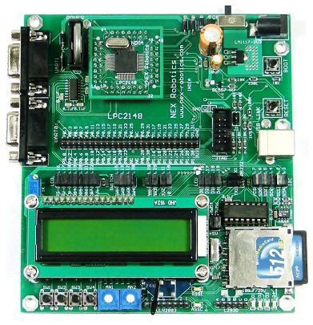

***Fig1.1 ARM- LPC2148***

**B. GSM Module**

GSM stands for Global System for Mobile Communications.GSM is one of the leading digital cellular systems.GSM was first introduced in 1991and as of the end of 1997. GSM service was available in more than 100 countries and has become the de standard in Europe and Asia. GSM uses narrowband TDMA, which allows eight simultaneous calls on the same radio frequency.GSM is compatibility that we can use the same mobile to make calls in several countries.GSM has Noise Robust such that digital GSM is better than analog because it suffer from noise therefore using digital will reduce the noise interference.GSM has flexibility and increased capacity due to equipment is smaller in size.GSM is Secured and confidentiality such that GSM offers increase defence against eavesdropping. Enhanced range services such that the services available the speech services including Telephony and emergency calls, Data services including Short Message Service (SMS), cell Broadcast and supplementary services which charge extra including number identification, call baring, call forwarding and call completion.

Any GSM module is using the normal GSM network. GSM modules can be communicated to LPC2148- microcontroller using normal serial USART protocol. Communication is being done using regular GSM modem AT commands. The GSM module is shown in Fig1.2.

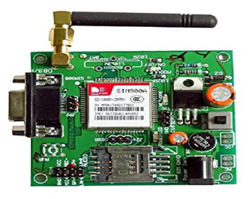

***Fig1.2.GSM Module***

**C. ZigBee Module**

ZigBee is a new wireless technology .ZigBee is a technological standard created for control and sensor networks. ZigBee is based on the IEEE 802.15.4 Standard. ZigBee is created by the ZigBee Alliance. Philips, Motorola, Intel, HP are all members of the alliance. ZigBee is designed for low power consumption allowing batteries to essentially last forever. ZigBee makes possible completely networked homes where all devices are able to communicate and be controlled by a single unit. It provides network, security and application support services operating on the top of IEEE.

It is used for embedded application for low data rates and Low power consumption, In expensive, Small packet networks, Home Entertainment and Control, Wireless sensor network’s.

ZigBee Architecture is a layered architecture. These layers facilitate the features that make ZigBee very attractive: low cost, easy implementation, reliable data transfer, short-range operations, very low power consumption and adequate security features. There are three Layers of ZigBee Module. They are Network and Application Support layer, Physical (PHY) layer and Media access control (MAC) layer.

ZigBee applications are the ZigBee Alliance targets applications Across consumer, commercial, industrial and government markets worldwide, Home networking, Industrial control and management.

In future all devices and their controls will be based on this standard. Since Wireless personal Area Networking applies not only to household devices, but also to individualized office automation applications, ZigBee is here to stay. It is more than likely the basis of future home-networking solutions. The ZigBee module is shown in Fig1.3.

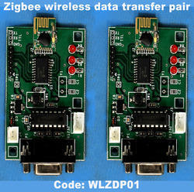

***Fig1.3.ZigBee Module***

**1.3.2. Software Tools:**

**A. Keiluv4 IDE Tool:**

Keil was founded in 1982 by Gunter and Reinhard Keil; initially as a German GbR. In April 1985 the company was converted to Keil Electronic GmbH to market add-on products for the development tools provided by many of the Silicon vendors. Keil implemented the first C compiler designed from the ground-up specifically for the 8051 microcontroller. Keil provides a broad range of development tools like ANSI C compiler, macro assemblers, debuggers and simulators, linkers, IDE, library managers, real-time operating systems and evaluation boards for Intel 8051, Intel MCS-251, ARM, andXC16x/C16x/ST10families.

**B. Proteus_v7.8i:**

The ProteusDesignSuite is an Electronic Design Automation (EDA) tool including schematic capture, simulation and PCB Layout modules. The Proteus Design Suite is the tool used for simulation before executing the code in a circuit board because of safety of a kit. It is developed in Yorkshire, England by Lab center Electronics Ltd with offices in North America and several overseas sales channels. The software runs on the Windows operating system and is available in English, French, Spanish and Chinese languages.

**C. HYPERTERMINAL:**

HyperTerminal is also known as HyperAccess. HyperTerminal is used to show the output in a personal computer with the help of ZigBee. HyperAccessis a family of terminal emulation software by Hilgraeve. A version of HyperAccess, called HyperTerminal is included in some versions of Windows.

**D. Flash MAGIC:**

The Flash Magic is an affordable, reliable, and fast programmer for LPC2148 Microcontrollers and 24Cxx I2C EEPROMs. This Flash Magic tool is used to dump the code into a device. The programmer is designed to operate with the Intel Pentium-based IBM- compatible desktop computers. The menu-driven software interface makes it easy to operate. *Hardware features* are single 40 Pin ZIF for 8 to 40 Pin Devices, USB Interface, Programmer firmware update through computer, ISP programming supported.

*Software features* are works on Win Xp Operating System. User-friendly interfaces with pull-down menus. Pop-up dialogue box and help, Device insertion test, Support all operations, such as read, blank check, erase, program, secure, & verify. Easy to use integrated HEX Editor on main software window. Supports Intel (linear & segmented) HEX (INHX8M). Auto Batch Program function for faster programming i.e. Mass Production mode. Automatic device identification before programming. Support for programming only a selected memory in the microcontroller. e.g. Data memory or Fuse Bits.

**1.4 Organization of the Project:**

The **CHAPTER 1** describes the introduction of the project, Objective of the project, Literature Survey.

The **CHAPTER 2** describes the general theory of the project like embedded system, Microcontroller used.

The **CHAPTER 3** describes the Block Diagram, Overview of Block Diagram, Explanation of Hardware blocks used in the project like Microcontroller (ARM 7), GSM module, ZigBee module, Fire sensor, Gas sensor, Smoke sensor, PIR sensor, IR sensor, LCD Display, ULN2003 Relay, DC motor, Cooling fan, PC, L293D Motor driver, Voltage regulator (7805) and Buzzer are used.

The **CHAPTER 4** describes the Software Tools used like Keiluv4 IDE Tool, Proteus_v7.8i, HyperTerminal, Flash Magic, Embedded C language, and Program.

The **CHAPTER 5** describes the Specifications of the project, results.

**CHAPTER 2**

**GENERAL THEORY**

**2.1 Embedded systems:**

A system is something that maintains its existence and functions as a whole through the interaction of its parts. E.g. Body, Mankind, Access Control, etc A system is a part of the world that a person or group of persons during some time interval and for some purpose choose to regard as a whole, consisting of interrelated components, each component characterized by properties that are selected as being relevant to the purpose.

Embedded System is a combination of hardware and software used to achieve a single specific task. Embedded systems are computer systems that monitor, respond to, or control an external environment.

An embedded system is a [computer](https://en.wikipedia.org/wiki/Computer) [system](https://en.wikipedia.org/wiki/System) with a dedicated function within a larger mechanical or electrical system, often with [real-time computing](https://en.wikipedia.org/wiki/Real-time_computing) constraints. It is embedded as part of a complete device often including hardware and mechanical parts. Embedded systems control many devices in common use today. Ninety-eight percent of all [microprocessors](https://en.wikipedia.org/wiki/Microprocessors) are manufactured as components of embedded systems.

Today they are widely used to serve various purposes like:

* Network equipment such as firewall, router, switch, and so on.
* Consumer equipment such as MP3 players, cell phones, PDAs, digital cameras, camcorders, home entertainment systems and so on.
* Household appliances such as microwaves, washing machines, televisions and so on.
* Mission-critical systems such as satellites and flight control.

**The key factors that differentiate embedded system from a desktop computer:**

* They are cost sensitive.
* Most embedded systems have real time constraints.
* There are multitudes of CPU architectures such as ARM, MIPS, and PowerPC that are used in embedded systems.
* Application-specific processors are employed in embedded systems.

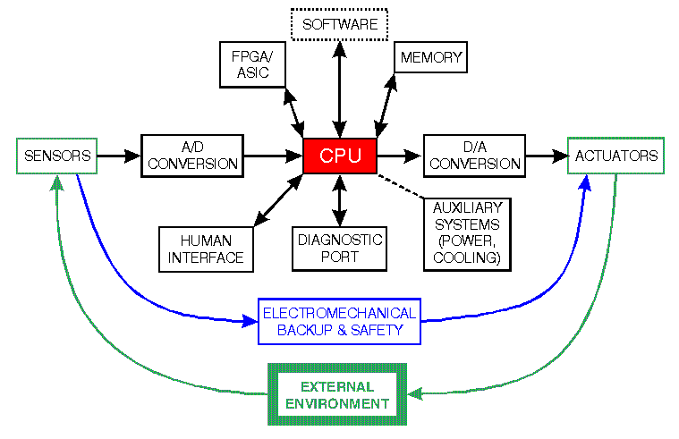**2.1.1** **Block Diagram of Embedded System:**

***Fig. 2.1: Block Diagram for Embedded System***

**2.1.2 Design of Embedded System:**

Like every other system development design cycle embedded system too have a design cycle. The flow of the system will be like as given below:

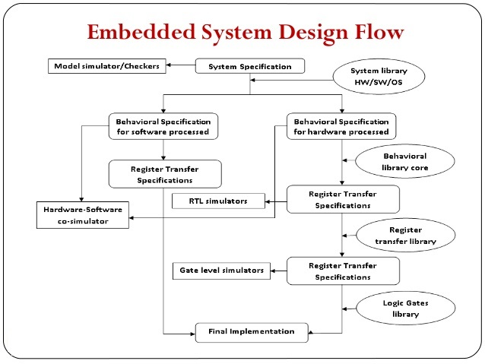

***Fig.2.2 Flow chart of the Embedded System***

**2.1.3 Classification of Embedded System:**

* Real Time Systems.
* RTS is one which has to respond to events within a specified deadline.
* A right answer after the dead line is a wrong answer
* RTS classification
  + 1. Hard Real Time Systems
    2. Soft Real Time Systems

**1. Hard Real Time Systems:**

"Hard" real-time systems have very narrow response time. Tasks have to performed not only correctly but also in time. Failure to comply to the set deadlines would result catastrophically.Example: Nuclear power system, Cardiac pacemaker.

**2. Soft Real Time System:**

"Soft" real-time systems have reduced constrains on "lateness" but still must operate very quickly and repeatable. Tasks are performed by the systems as fast as possible, but failing to complete within specified deadlines is nor catastrophically.Example: Railway reservation system – takes a few extra seconds the data remains valid. Video Surveillance, Radio Transmissions.

**2.1.4 Embedded systems often share the following attributes:**

1. They are tightly connected to the outside world via sensors and actuators (i.e., motors, relays, switches, etc.). The outside world is not as clean as the digital world inside your software (noise, disturbance, debouncing of switches, etc.).
2. They often monitor and control processes.
3. Data logging and transformations is less important.
4. They have a minimal user interface.
5. They start on power up and have to remain operational until the power is removed (Reliability is important: A VCR, which crashes while you are watching a movie, is not acceptable).
6. The environment in which the system is going to operate and the production method/run pose requirements on embedded systems, regarding:

* Price of parts
* In-circuit programmability
* Environmental requirements
* Temperature ranges
* Vibrations
* Humidity

### 2.1.5 Categories of Embedded System

### 1. Application Specific Systems.

2. Distributed Systems.

3. Reactive Embedded Systems.

4. Heterogeneous Systems.

#### 1. Application Specific Systems

Embedded systems are not general-purpose computers. Embedded system designs are optimized for a specific application. Many of the job characteristics are known before the hardware is designed. This allows the designer to focus on the specific design constraints of a well-defined application. As such, there is limited user reprogram ability. Some embedded systems, however, require the flexibility of re-programmability. Programmable DSPs are common for such applications.

#### 2. Distributed Systems

A common characteristic of an embedded system is that it consists of communicating processes executing on several CPUs or ASICs, which are connected by communication links. The reason for this is economy. Economical four 8-bit microcontrollers may be cheaper than a 32-bit processor. Even after adding the cost of the communication links, this approach may be preferable. In this approach, multiple processors are usually required to handle multiple time-critical tasks. Devices under control of embedded systems may also be physically distributed.

### *3. Reactive Embedded Systems*

A typical embedded systems model responds to the environment via sensors and control the environment using actuators. This requires embedded systems to run at the speed of the environment. This characteristic of embedded system is called “reactive”. Reactive computation means that the system (primarily the software component) executes in response to external events.

External events can be either periodic or Aperiodic. Periodic events make it easier to schedule processing to guarantee performance. Aperiodic events are harder to schedule. The maximum event arrival rate must be estimated in order to accommodate worst case situations. Most embedded systems have a significant reactive component.

### *4. Heterogeneous Systems*

Embedded systems often are composed of heterogeneous architectures. They may contain different processors in the same system solution. They may also be mixed signal systems. The combination of I/O interfaces, local and remote memories, and sensors and actuators makes embedded system design truly unique. Embedded systems also have tight design constraints and heterogeneity provides better design flexibility.

### 2.1.6 Requirement of Embedded Systems

Embedded systems are unique in several ways, as described above. When designing embedded systems, there are several categories of requirements that should be considered:

1. Functional Requirements

2. Temporal Requirements (Timeliness)

3. Dependability Requirements.

#### 1. Functional Requirements

Functional requirements describe the type of processing the system will perform. This processing varies, based on the application. Functional requirements include the following;

* Data collection requirements
* Sensor requirements
* Signal conditioning requirements
* Alarm monitoring requirements
* Direct digital control requirements
* Actuator control requirements
* Man-machine interaction requirements

#### 2. Temporal Requirement

Embedded systems have many tasks to perform, each having its own deadline. Temporal requirements define the stringency in which these time-based tasks must complete. Examples

include:

* Minimal latency jitter
* Minimal error-detection latency temporal requirements can be very tight (for example, control-loops) or less stringent (for example, response time in a user interfaces).

#### 3. Dependability Requirements

Most embedded systems also have a set of dependability requirements. Examples of dependability requirements include:

* *Reliability:* a complex concept that should always be considered at the system level rather than at the individual component level. There are three dimensions to consider when specifying system reliability.
* *Hardware reliability:* probability of a hardware component failing.
* *Software reliability:* probability that a software component will produce an incorrect result.
* *Operator reliability:* how likely that the operator of a system will make an error.

### 2.1.7 Microcontroller Selection

General factors that govern the selection are:

* Complexity of overall design
* Design reuse
* Performance
* Power size
* Cost tools
* Operating system support and availability

The design's complexity helps to determine which CPU to use. If the design calls for the deployment of a single state machine with interrupts from a small set of peripherals, then a small CPU and/or micro controller such as the MCS51 or the Z80 could be the best choice. Many systems such as industrial timer may fit this category, as the memory footprint is small, the signal is slow and battery consumption must be extremely low. The application and its interaction will dictate the design's complexity and may also determine whether it requires a real-time operating system (RTOS). Typically, as the complexity of the application increases, the need for a greater bit-width processor increases. The selection of the CPU will greatly impact performance of the overall system. Specifically, features like 8/16/24/32 bit architecture, RISC / CISC / DSP architecture, cache, MMU, pipelining, branch prediction and super-scalar architecture, all affect the speed of a system. Depending on system needs, these features may be necessary to achieve peak performance of the system.

There are various benchmarking threshold data available for various 8/16/32 bit processors like MIPS (Million Instructions per Second), EEMBC, Dhrystone, MIPS/MHz, etc., which can be taken as reference or comparison base

**2.1.8 CISC Vs RISC:-**

CISC is an acronym for Complex Instruction Set Computer and are chips that are easy to program and which make efficient use of memory. Since the earliest machines were programmed in assembly language and memory was slow and expensive, the CISC philosophy made sense, and was commonly implemented in such large computers as the PDP-11 and the DEC system 10 and 20 machines. Most common microprocessor designs such as the Intel 80x86 and Motorola 68K series followed the CISC philosophy. But recent changes in software and hardware technology have forced a re-examination of CISC. Many modern CISC processors are hybrids, implementing many RISC principles.

The design constraints that led to the development of CISC (small amounts of slow memory and fact that most early machines were programmed in assembly language) give *CISC instructions sets some common characteristics:*

A 2-operand format, where instructions have a source and a destination that include register to register, register to memory and memory to register commands.

Multiple addressing modes for memory, including specialized modes for indexing through arrays.

Variable length instructions, where the length often varies according to the addressing mode. Instructions, which require multiple clock cycles to execute.

Complex instruction-decoding logic, driven by the need for a single instruction to support multiple addressing modes.

A small number of general purpose registers. This is the direct result of having instructions which can operate directly on memory and the limited amount of chip space not dedicated to instruction decoding, execution and microcode storage.

Several special purposes register. Many CTSC designs set aside special registers for the stack pointer, interrupt handling, and so on. This can simplify the hardware design somewhat, at the expense of making the instruction set more complex.

A 'Condition code" register, which is set as a side-effect of most instructions. This register reflects whether the result of the last operation is less than, equal to, or greater than zero and records if certain error conditions occur.

At the time of their initial development, CISC machines used available technologies to optimize computer performance.

Microprogramming is as easy as assembly language to implement and much less expensive than hardwiring a control unit.

The ease of microcoding new instructions allowed designers to make CISC machines upwardly compatible: a new computer could run the same programs as earlier computers because the new computer would contain a superset of the instructions of the earlier computers.

As each instruction became more capable, fewer instructions could be used to implement a given task. This made more efficient use of the relatively slow main memory.

Because microprogram instruction sets can be written to match the constructs of high-level languages, the compiler does not have to be as complicated.

Designers soon realized that the CISC philosophy had its own problems, including:Earlier generations of a processor family generally were contained as a subset in every new version.So instruction set & chip hardware become more complex with each generation of computers.

As many instructions as possible could be stored in memory with the least possible wasted space, individual instructions could be of almost any length - this means that different instructions will take different amounts of clock time to execute, slowing down the overall performance of the machine.

Many specialized instructions aren't used frequently enough to justify their existence—approximately 20% of the available instructions are used in a typical program.

CISC instructions typically set the condition codes as a side effect of the instruction. Not only does setting the condition codes take time, but programmers have to remember to examine the condition code bits before a subsequent instruction changes them.

As memory speed increased, and high-level languages displaced assembly language, the major reasons for CISC began to disappear, and computer designers began to look at ways computer performance could be optimized beyond just making faster hardware.

One of their key realizations was that a sequence of simple instructions produces the same results as a sequence of complex instructions, but can be implemented with a simpler (and faster) hardware design (assuming that memory can keep up.) RISC (Reduced Instruction Set Computers) processors were the result. CISC and RISC implementations are becoming more and more alike. Many of today’s RISC chips support as many instructions as yesterday's CISC chips. And today's CISC chips use many techniques formerly associated with RISC chips.

### 2.1.9 RISC Technology

Pronounced 'risk', RISC is an acronym for Reduced Instruction Set Computer and is a type of microprocessor that recognizes a relatively limited number of instructions. Until the mid-1980s, the tendency among computer manufacturers was to build increasingly complex CPUs that had ever-larger sets of instructions. At that time, however, a number of computer manufacturers decided to reverse this trend by building CPUs capable of executing only a very limited set of instructions. One advantage of reduced instruction set computers is that they can execute their instructions very fast because the instructions are so simple. Another, perhaps more important advantage, is that RISC chips require fewer transistors, which makes them cheaper to design and produce. Since the emergence of RISC computers, conventional computers have been referred to as CISC's (Complex Instruction Set Computers).

The main characteristics of CISC microprocessors are:

* Extensive instructions
* Complex and efficient machine instructions
* Micro-encoding of the machine instructions
* Extensive addressing capabilities for memory operations
* Relatively few registers

In comparison, RISC processors are more or less the opposite of the above:

* Reduced instruction set
* Less complex, simple instructions
* Hardwired control unit and machine instructions
* Few addressing schemes for memory operands with only two basic instructions (LOAD and STORE)
* Many symmetric registers, which are organized into a register file

There is still considerable controversy among experts about the ultimate value of RISC architectures. Its proponents argue that RISC machines are both cheaper and faster, and are therefore the machines of the future.

However, by making the hardware simpler, RISC architectures put a greater burden on the software. Is this worth the trouble because conventional microprocessors are becoming increasingly fast and cheap anyway?

To some extent, the argument is becoming doubtful because CISC and RISC implementations are becoming more and more alike. Many of today's RISC chips support as many instructions as yesterday's CISC chips. And today's CISC chips use many techniques formerly associated with RISC chips.

The RISC concepts of the individual manufacturers are naturally, slightly different. However many of the essential points are similar, such as:

* Reduction of the instruction set.
* Instruction pipelining (the interleaved execution of many instructions).
* Load/store architecture (only the load and store instructions have access to memory, all others work with the internal processor registers).
* Unity of RISC processors and compilers (the compiler is no longer developed for a specific chip, but instead, at the outset, the compiler is developed in conjunction with the chip to produce one unit).
* A modified register concept—in some RISC processors, for a fast subroutine call, the registers are no longer managed as ax, bx, etc., but exist in the form of a variable window, which allows a 'look' at certain register files.

Closely related to the abbreviation RISC is the reduction of almost unlimited instruction set of highly complex CISCs. One of the first prototypes that implemented the RISC concept RISC-I, had 31 instructions, whereas its successor, the RISC II, had 39.

The simplicity of processor structure is shown by the reduced number of integrated transistors: in the RISC II there are only 41000 (in comparison to more than one million in the 486 and three million in the Pentium).

One additional very important characteristic is the hardwired Control Unit CU (the instructions are hard wired) This means that in a RISC processor, the Execution Unit EU is no longer controlled by the CU with the assistance of extensive micro codes. Instead, the whole operation is achieved in the form of hardwired logic. This greatly accelerates the execution of an instruction.

For example, in a CISC the complexity of a multiplication instruction is located in a very extensive microcode which controls the ALU. For a RISC CPU, the chip designers put the complexity in a complicated hardware multiplier. Typically, in a CISC CPU multiplications are carried out by many additions and shifts, whereas a RISC multiplier performs that operation in one or two (dependent on the precision) passes.

Due to the reduced number of machine instructions, there is now enough space on the chip for implementing such highly complex circuitries. The execution structure of an instruction is, as a result of the basic microprocessor working principles, the same for the majority of machine code instructions.

The following steps must be carried out:

* Read the instruction from memory (instruction fetching).
* Decode the instruction (decoding phase).
* Where necessary, fetch operand(s) (operand fetching phase).
* Execute the instruction (execution phase).
* Write back the result (write-back phase).

Every instruction is broken down into partial steps for execution in the stage pipeline. The partial steps are executed within one single clock cycle i.e., instruction 'k' needs five clock cycles to complete but then at the pipeline output, an instruction result is available with each clock cycle.

**2.2 Microcontroller (LPC 2148)**

ARM- LPC2148 is a microcontroller board capable of performing very easy accessibility of the interacting environments. This board has a specially designed circuit board for programming and prototyping with microcontrollers. ARM- LPC2148 is an open source platform in which many real time hardware's can be interfaced with greater compatibility. Also any hardware or software up gradation is easily possible. The ARM- LPC2148 is just a microcontroller board . ARM- LPC2148 is a 32-bit ARM7TDMI-S microcontroller. It has40 kB of on-chip static RAM and 32 kB to 512 kB of on-chip flash memory. It consists of In-System Programming/In-Application Programming (ISP/IAP)‏. It has 8 kB of on-chip RAM accessible to USB by DMA. It has Two 10-bit ADCs provide a total of 14 analog inputs. It has 10-bit DAC provides variable analog output. It has Two 32-bit timers/external event counters (with four capture and four compare channels each)‏. It has PWM unit (six outputs).ARM-LPC2148 consists of watchdog timer, Real-Time Clock (RTC) with independent power. ARM-LPC2148 consists of Multiple serial interfaces including two UARTs, Two Fast I2C-bus (400 kbit/s), SPI and SSP with buffering and variable data length capabilities. It has Vectored Interrupt Controller (VIC) with configurable priorities and vector addresses. It has 45 general purpose I/O pins. It has 21 external interrupt pins available. It has On-chip integrated oscillator operates with an external crystal from 1 MHz to 25 MHz.

**2.3 Power Supply**

A power supply is an electronic device that supplies [electric energy](https://en.wikipedia.org/wiki/Electric_energy) to an [electrical load](https://en.wikipedia.org/wiki/Electrical_load). The primary function of a power supply is to convert one form of electrical energy to another and, as a result, power supplies are sometimes referred to as [electric power converters](https://en.wikipedia.org/wiki/Electric_power_converter). Some power supplies are discrete, stand-alone devices, whereas others are built into larger devices along with their loads. Examples of the latter include power supplies found in [desktop computers](https://en.wikipedia.org/wiki/Desktop_computer) and [consumer electronics](https://en.wikipedia.org/wiki/Consumer_electronics) devices. Every power supply must obtain the energy it supplies to its load, as well as any energy it consumes while performing that task, from an energy source. Depending on its design, a power supply may obtain energy from various types of energy sources, including electrical energy transmission systems, [energy storage](https://en.wikipedia.org/wiki/Energy_storage) devices such as a [batteries](https://en.wikipedia.org/wiki/Battery_(electricity)) and [fuel cells](https://en.wikipedia.org/wiki/Fuel_cell), electromechanical systems such as generators and [alternators](https://en.wikipedia.org/wiki/Alternator), [solar power](https://en.wikipedia.org/wiki/Solar_power) converters, or another power supply.

The power supply is designed to convert high voltage AC mains electricity to a suitable low voltage supply for electronic circuits and other devices. A power supply can by broken down into a series of which maintains the output voltage constant irrespective of a.c mains fluctuations or load variations is known as “Regulated D.C Power Supply.

The complete DC power supply design combines the full wave rectifier and the LM317 regulator. This design is simple and is low cost. The main problem is that it is not very efficient. This set up would not be good in a battery application but if the application can be plugged into the wall this set up can save a lot of money. The total cost is around $3.00. This design takes the power from the wall, which has AC. Then using a regulator takes ripple current from the rectifier and outputs a constant DC output.

This DC output is very useful to power microchips and different ICs. Once a ripple output is established from the Full wave rectifier a stable voltage needs to be created. A stable voltage is needed for consistent operation from the connected circuit. The cheapest and most cost effective way is to use a linear regulator. A regulator does exactly what the name says, it regulates the voltage. Using the voltage input a regulator generates an internal voltage for the regulator to compare the output to be able to hold the output constant.

**CHAPTER 3**

**HARDWARE DESCRIPTION**

**3.1 BLOCK OF THE PROPOSED SYSTEM WITH IMPLEMENTATION**



***Fig3.1. Block diagram of the transmitter for the proposed system.***

The block diagram of the transmitter proposed system is shown in Fig3.1. In this work, five process variables like gas leakage, fire detector, moving motion detector , obstacle identifier and fuel level of a tank are taken for measurement with the help of Gas Sensor, Fire Sensor, IR Sensor, PIR Sensor and Ultrasonic Level Sensors. These sensors are attached to the Microcontroller. These sensors are used to detect the leakage of gas, fire detection, moving motion detection for security purpose, obstacle identifier and fuel level of a tank and finds its application for industrial purposes.

The block diagram of the transmitter proposed system is shown in Fig3.1. In this work, The sensors output obtained from gas leakage, fire detector, moving motion detector , obstacle identifier and fuel level of a tank is given to microcontroller device for further processing. The microcontroller device used here is an LPC2148 Microcontroller board which comprises the controller, GSM module and ZigBee module.



***Fig3.2. Block diagram of the receiver for the proposed system.***

The block diagram of the receiver for the proposed system is shown in Fig3.2.The GSM module board contains the algorithm for communicating with the mobile using GSM Sim through cellular mobile communication. The mobile has an algorithm to communicate with the GSM module device via cellular mobile communication as well as to store and display the results in terms of SMS . The monitor screen on the mobile exhibits the real time values of level detector, gas detection, fire detection, moving motion detection and obstacle detection by displaying the message continuously and thereby helping the operator to monitor the messages or values in the process environment in a movable manner.

We can monitor the industrial parameters such as gas, liquid level, human detection, fire. If fire detected buzzer will on and a cooling fan switched on. If gas leaked buzzer will on. If liquid overflows buzzer will on. For security purpose human detection sensor can be used. If any obstacle find the robot will change the direction by using IR sensor. All the parameters are send via GSM and ZigBee.

**3.2 HARDWARE COMPONENTS**

* LPC2148 ARM Microcontroller.
* GSM Module.
* ZigBee module.
* Fire Sensor.
* GAS Sensor.
* Level Sensor.
* PIR Sensor.
* IR Sensor.
* LCD Display.
* ULN2003 Relay Driver.
* Cooling Fan.
* PC.
* L293D Motor Driver.
* DC Motors.
* Voltage Regulator (7805).
* Buzzer.

**3.2.1 LPC2148 ARM Microcontroller**

ARM- LPC2148 is a microcontroller board capable of performing very easy accessibility of the interacting environments. This board has a specially designed circuit board for programming and prototyping with microcontrollers. ARM- LPC2148 is an open source platform in which many real time hardware's can be interfaced with greater compatibility. Also any hardware or software up gradation is easily possible. The ARM- LPC2148 is just a microcontroller board . ARM- LPC2148 is a 32-bit ARM7TDMI-S microcontroller. It has40 kB of on-chip static RAM and 32 kB to 512 kB of on-chip flash memory. It consists of In-System Programming/In-Application Programming (ISP/IAP)‏. It has 8 kB of on-chip RAM accessible to USB by DMA. It has Two 10-bit ADCs provide a total of 14 analog inputs. It has 10-bit DAC provides variable analog output. It has Two 32-bit timers/external event counters (with four capture and four compare channels each)‏. It has PWM unit (six outputs).ARM-LPC2148 consists of watchdog timer, Real-Time Clock (RTC) with independent power. ARM-LPC2148 consists of Multiple serial interfaces including two UARTs, Two Fast I2C-bus (400 kbit/s), SPI and SSP with buffering and variable data length capabilities. It has Vectored Interrupt Controller (VIC) with configurable priorities and vector addresses. It has 45 general purpose I/O pins. It has 21 external interrupt pins available. It has On-chip integrated oscillator operates with an external crystal from 1 MHz to 25 MHz.

**Features of LPC2148 Microcontroller :-**

* 16/32-bit ARM7TDMI-S microcontroller in a tiny LQFP64 package.
* 8 to 40 kB of on-chip static RAM and 32 to 512 kB of on-chip flash program memory.
* 128 bit wide interface/accelerator enables high speed 60 MHz operation.
* In-System/In-Application Programming (ISP/IAP) via on-chip boot-loader software. Single flash sector or full chip erase in 400 ms and programming of 256 bytes in 1 ms.
* Embedded ICE RT and Embedded Trace interfaces offer real-time debugging with the on-chip real monitor software and high speed tracing of instruction execution.
* USB 2.0 Full Speed compliant Device Controller with 2 kB of endpoint RAM. In addition, the LPC2146/8 provide 8 kB of on-chip RAM accessible to USB by DMA.
* One or two (LPC2141/2 vs. LPC2144/6/8) 10-bit A/D converters provide a total of 6/14 analog inputs, with conversion times as low as 2.44 μs per channel.
* Single 10-bit D/A converter provides variable analog output.
* Two 32-bit timers/external event counters (with four capture and four compare channels each), PWM unit (six outputs) and watchdog.
* Low power real-time clock with independent power and dedicated 32 kHz clock input.
* Multiple serial interfaces including two UARTs (16C550), two Fast I2C-bus (400 kbit/s), SPI and SSP with buffering and variable data length capabilities.
* Vectored interrupt controller with configurable priorities and vector addresses. Up to 45 of 5 V tolerant fast general purpose I/O pins in a tiny LQFP64 package.
* Up to nine edge or level sensitive external interrupt pins available.
* 60 MHz maximum CPU clock available from programmable on-chip PLL with settling time of 100 μs.
* On-chip integrated oscillator operates with an external crystal in range from 1 MHz to 30 MHz and with an external oscillator up to 50 MHz.
* Power saving modes include Idle and Power-down.
* Individual enable/disable of peripheral functions as well as peripheral clock scaling for additional power optimization.
* Processor wake-up from Power-down mode via external interrupt, USB, Brown-Out Detect (BOD) or Real-Time Clock (RTC).
* Single power supply chip with Power-On Reset (POR) and BOD circuits: CPU operating voltage range of 3.0 V to 3.6 V (3.3 V ± 10 %) with 5 V tolerant I/O pads.

**Description about the Block Diagram :-**

* *On chip Flash Program Memory :* **-** LPC 2148 is having 512 kB Flash memory. This memory may be used for both code and data storage. Programming of the flash memory may be accomplished in several ways(ISP/IAP).
* *On chip Static RAM :-*On-chip static RAM may be used for code and/or data storage. The SRAM may be accessed as 8-bit, 16-bit, and 32 bit. An 8 kB SRAM block intended to be utilized mainly by the USB.
* *Interrupt Controller :-*The Vectored Interrupt Controller (VIC) accepts all of the interrupt request inputs and categorizes them as Fast Interrupt Request (FIQ), vectored Interrupt Request (IRQ), and non-vectored IRQ as defined by programmable settings.
* *Analog to Digital Converter :-*LPC2148 contains two analog to digital converters(ADC0 & ADC1 ). Total number of available ADC inputs is 14. These two ADC’s are 10 bit successive approximation analog to digital converters. Measurement range of 0 V to VREF.
* *Digital to Analog Converter :-*The DAC enables to generate a variable analog output. The maximum DAC output voltage is the VREF voltage. 10-bit DAC. Buffered output. Power-down mode available.
* *USB 2.0 Device Controller :-*The USB is a 4-wire serial bus that supports communication between a host and a number (127 max) of peripherals. Enables 12 Mbit/s data exchange with a USB host controller.
* *UART :****-*** LPC2148 contains two UARTs( UART0 & UART1). In addition to standard transmit and receive data lines, the LPC2148 UART1 also provides a full modem control handshake interface. 16 byte Receive and Transmit FIFOs.
* *I2C-bus serial I/O controller :-* I2C is a bidirectional. It is a multi-master bus, it can be controlled by more than one bus master connected to it. It supports bit rates up to 400 kbit/s. Bidirectional data transfer between masters and slaves. Serial clock synchronization allows devices with different bit rates to communicate via one serial bus.
* *SPI serial I/O control :-* It is s a full duplex serial interface, designed to handle multiple masters and slaves connected to a given bus. Synchronous, Serial, Full Duplex Communication.
* *SSP serial I/O control :-* Supports full duplex transfers. Data frames of 4 bits to 16 bits of data flowing from the master to the slave and from the slave to the master. Synchronous serial communication.
* *Timers :-* LPC 2148 has two 32-bit timer/counters with a programmable 32-bit prescaler. It also having external event counter.

It is also having Four 32-bit match registers that allow:

* Continuous operation with optional interrupt generation on match.
* Stop timer on match with optional interrupt generation.
* Reset timer on match with optional interrupt generation.
* *Watchdog Timer :-*The purpose of the watchdog is to reset the microcontroller within a reasonable amount of time if it enters an erroneous state.
* *Real Time Clock :-*The RTC is designed to provide a set of counters to measure time when normal or idle operating mode is selected. The RTC has been designed to use little power, making it suitable for battery powered systems where the CPU is not running continuously (Idle mode).
* *Crystal Oscillator :-*On-chip integrated oscillator operates with external crystal in range of 1 MHz to 25 MHz.
* *PLL :-*The PLL accepts an input clock frequency in the range of 10 MHz to 25 MHz. The input frequency is multiplied up into the range of 10 MHz to 60 MHz with a Current Controlled Oscillator (CCO).

**General Purpose Input/output ports (GPIO)**

Every physical GPIO port is accessible either the group of registers by providing an enhanced features and accelerated port access or the legacy group of registers.

Accelerated GPIO functions:

* GPIO registers are relocated to the ARM local bus so that the fastest possible I/O timing can be achieved.
* Mask registers allow treating sets of port bits as a group, leaving other bits unchanged.
* All registers are byte and half-word addressable.
* Entire port value can be written in one instruction.
* Bit-level set and clear registers allow a single instruction set or clear of any number of bits in one port.
* Direction control of individual bits.
* All I/O default to inputs after reset.

**Applications of LPC 2148:**

* General purpose I/O.
* Driving LEDs, or other indicators.
* Controlling off-chip devices.
* Sensing digital inputs.

**Advantages of LPC 2148:**

* Reliability.
* Flexibility in programming and reprogramming.
* Cost effective for controlling complex systems.
* Small physical size, shorter project time.
* High speed of operation.
* Ability to communicate with computer systems in the plant.
* Ease of maintenance /troubleshooting.
* Reduced space.
* Energy saving.

**Block Diagram of LPC2148 Microcontroller :-**

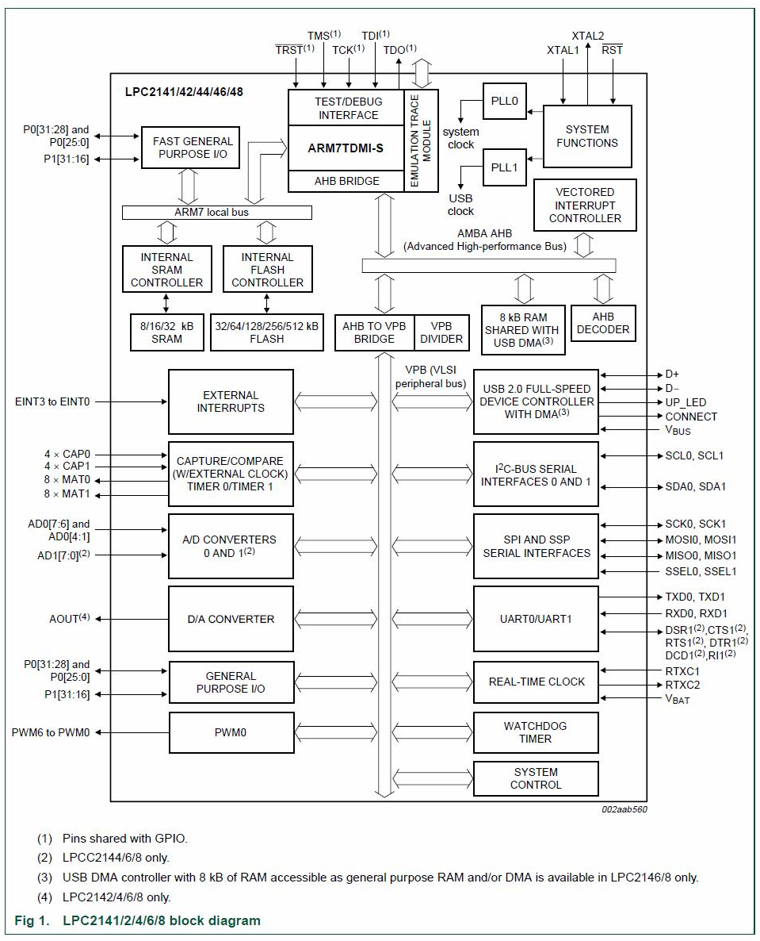

***Fig3.3 Block Diagram of LPC2148 Microcontroller.***

**PIN diagram of LPC 2148:-**



***Fig3.4 PIN diagram of LPC 2148***

**PIN Select Register :-**

The PINSEL register's controls the functions of the pins . In LPC 2148 we are having 3pinselect Registers. They are

1. PINSEL0

2. PINSEL1

3. PINSEL2

**TRANSFORMER:**

A transformer is an electrical device which is used to convert electrical power from one Electrical circuit to another without change in frequency. When AC is applied to the primary winding of the power transformer it can either be stepped down or up depending on the value of DC needed. In our circuit the transformer of 230v/15-0-15v is used to perform the step down operation where a 230V AC appears as 15V AC across the secondary winding. One alteration of input causes the top of the transformer to be positive and the bottom negative.

The next alteration will temporarily cause the reverse. The current rating of the transformer used in our project is 2A. Apart from stepping down AC voltages, it gives isolation between the power source and power supply circuitries.

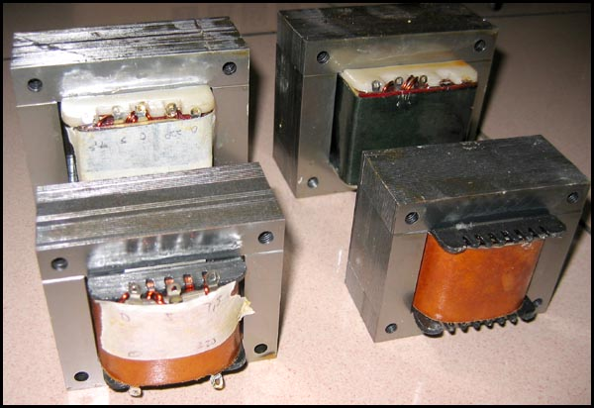

***Fig3.5: Electrical Transformers***

**RECTIFIER:**

A circuit which is used to convert a.c to dc is known as RECTIFIER. The process of conversion a.c to d.c is called “rectification.

***Comparison of rectifier circuits:***

|  |  |  |  |
| --- | --- | --- | --- |
| **Parameter** | **Type of Rectifier** | | |
| **Half wave Full wave Bridge** | | |
| Number of diodes | 1 | 2 | 4 |
| PIV of diodes | Vm | 2Vm | Vm |
| D.C output voltage | Vm/ | 2Vm/ | 2Vm/ |
| Vdc,at  No-load | 0.318Vm | 0.636Vm | 0.636Vm |
| Ripple factor | 1.21 | 0.482 | 0.482 |
| Ripple  Frequency | f | 2f | 2f |
| Rectification  Efficiency | 0.406 | 0.812 | 0.812 |
| Transformer  Utilization  Factor(TUF) | 0.287 | 0.693 | 0.812 |
| RMS voltage Vrms | Vm/2 | Vm/√2 | Vm/√2 |

**Table 3.1 : Comparisons of Rectifier Circuits**

In the power supply unit, rectification is normally achieved using a solid state diode. Diode has the property that will let the electron flow easily in one direction at proper biasing condition. As AC is applied to the diode, electrons only flow when the anode and cathode is negative. Reversing the polarity of voltage will not permit electron flow.

**Bridge Rectifier:**

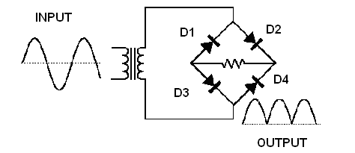

***Fig3.6: Bridge Rectifier***

***OPERATION:***

During positive half cycle of secondary, the diodes D2 and D3 are in forward biased while D1 and D4 are in reverse biased as shown in the fig(3.7). The current flow direction is shown in the fig (3.7) with dotted arrows.

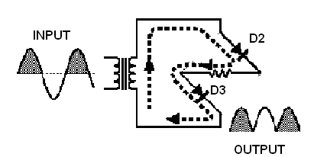

***Fig3.7:Operation During Positive Cycle***

During negative half cycle of secondary voltage, the diodes D1 and D4 are in forward biased while D2 and D3 are in reverse biased as shown in the Fig(3.8). The current flow direction is shown in the Fig (3.8) with dotted arrows.

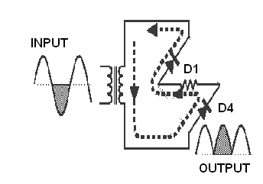

***Fig3.8 :Operations During Negative Cycle***

**FILTER:**

A Filter is a device which removes the AC component of rectifier output but allows the DC component to reach the load.

***Capacitor Filter:***

We have seen that the ripple content in the rectified output of half wave rectifier is **121%** or that of full-wave or bridge rectifier or bridge rectifier is **48%** such high percentages of ripples is not acceptable for most of the applications. Ripples can be removed by one of the following methods of filtering.

**(a)** A capacitor, in parallel to the load, provides an easier by –pass for the ripples voltage though it due to low impedance. At ripple frequency and leave the d.c.to appears the load.

**(b)** An inductor, in series with the load, prevents the passage of the ripple current (due to high impedance at ripple frequency) while allowing the d.c (due to low resistance to d.c)

**(c)** Various combinations of capacitor and inductor, such as L-section filter  section filter, multiple section filter etc.

**CAPACITORS:**

A capacitor or condenser is a passive electronic component consisting of a pair of conductors separated by a dielectric. When a voltage potential difference exists between the conductors, an electric field is present in the dielectric. This field stores energy and produces a mechanical force between the plates. The effect is greatest between wide, flat, parallel, narrowly separated conductors.

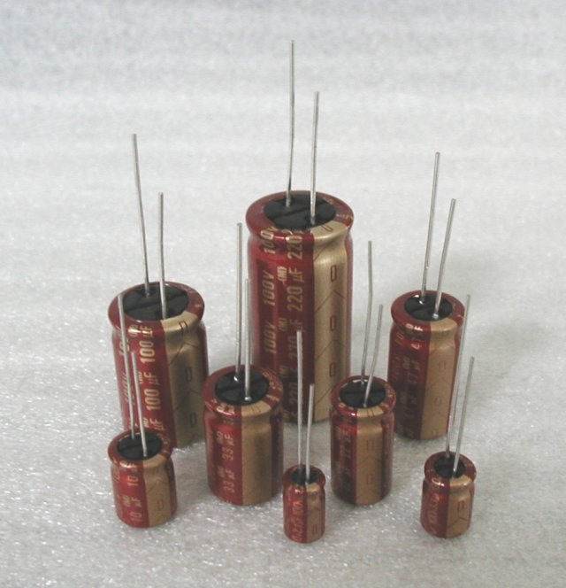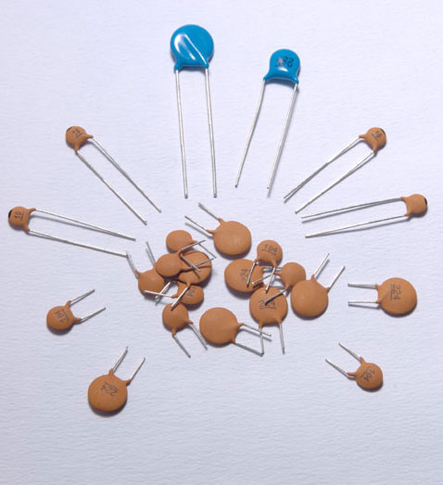

***Fig 3.9 Capacitor***

**RESISTORS**

A resistor is a two-terminal electronic component designed to oppose an electric current by producing a voltage drop between its terminals in proportion to the current, that is, in accordance with Ohm's law:

V = IR Where

V= Potential difference (V) between two points which includes resistance.

I= Current flowing through the resistance.

R= The constant of proportionality is called resistance.

Resistors are used as part of electrical networks and electronic circuits. They are extremely commonplace in most electronic equipment. Practical resistors can be made of various compounds and films, as well as resistance wire (wire made of a high-resistivity alloy, such as nickel/chrome).

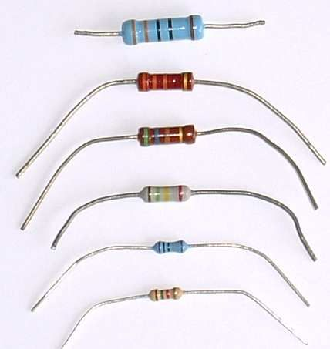

***Fig3.10 Resistor***

**3.2.2 GSM Module**

GSM stands for Global System for Mobile Communications.GSM is one of the leading digital cellular systems.GSM was first introduced in 1991and as of the end of 1997. GSM service was available in more than 100 countries and has become the de standard in Europe and Asia. GSM uses narrowband TDMA, which allows eight simultaneous calls on the same radio frequency.

GSM is compatibility that we can use the same mobile to make calls in several countries.GSM has Noise Robust such that digital GSM is better than analog because it suffer from noise therefore using digital will reduce the noise interference.GSM has flexibility and increased capacity due to equipment is smaller in size.

GSM is Secured and confidentiality such that GSM offers increase defence against eavesdropping. Enhanced range services such that the services available the speech services including Telephony and emergency calls.

Data services including Short Message Service (SMS), cell Broadcast and supplementary services which charge extra including number identification, call baring, call forwarding and call completion.

Any GSM module is using the normal GSM network. GSM modules can be communicated to LPC2148- microcontroller using normal serial USART protocol. Communication is being done using regular GSM modem AT commands. The GSM module is shown in Fig3.11.



***Fig3.11.GSM Module***

**AT Commands:**

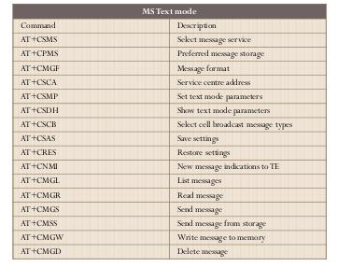

**AT Commands, SMS**

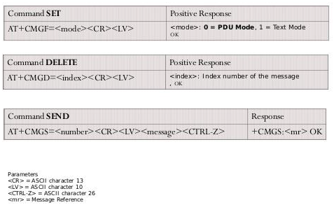

**3.2.3 ZigBee Module**

ZigBee is a new wireless technology .ZigBee is a technological standard created for control and sensor networks. ZigBee is based on the IEEE 802.15.4 Standard. ZigBee is created by the ZigBee Alliance. Philips, Motorola, Intel, HP are all members of the alliance. ZigBee is designed for low power consumption allowing batteries to essentially last forever. ZigBee makes possible completely networked homes where all devices are able to communicate and be controlled by a single unit. It provides network, security and application support services operating on the top of IEEE.

It is used for embedded application for low data rates and Low power consumption, In expensive, Small packet networks, Home Entertainment and Control, Wireless sensor network’s.

ZigBee Architecture is a layered architecture. These layers facilitate the features that make ZigBee very attractive: low cost, easy implementation, reliable data transfer, short-range operations, very low power consumption and adequate security features. There are three Layers of ZigBee Module. They are Network and Application Support layer, Physical (PHY) layer and Media access control (MAC) layer.

ZigBee applications are the ZigBee Alliance targets applications Across consumer, commercial, industrial and government markets worldwide, Home networking, Industrial control and management.

In future all devices and their controls will be based on this standard. Since Wireless personal Area Networking applies not only to household devices, but also to individualized office automation applications, ZigBee is here to stay. It is more than likely the basis of future home-networking solutions. The ZigBee module is shown in Fig3.12.



***Fig3.12 ZigBee Module***

**3.2.4 Fire Sensor**

Fire Sensor is also known has Flame Sensor Module.This module is sensitive to the flame and radiation. It also can detect ordinary light source in the range of a wavelength 760nm-1100 nm. The detection distance is up to 100 cm. The Flame sensor can output digital or analog signal. It can be used as a flame alarm or in fire fighting robots. Fire sensor detects a flame or a light source of a wavelength in the range of 760nm-1100 nm. The detection distance is 20cm (4.8V) to 100cm (1V).

The detection angle about 60 degrees, it is sensitive to the flame spectrum. The comparator chip LM393 makes module readings stable. Fire sensor has adjustable detection range. Fire sensor operating voltage is 3.3V-5V.

Fire sensor digital output is DO digital switch outputs (0 and 1). Fire sensor analog output is AO analog voltage output. Power indicator and digital switch output indicator are used in fire sensor. The fire sensor is shown in Fig3.13.

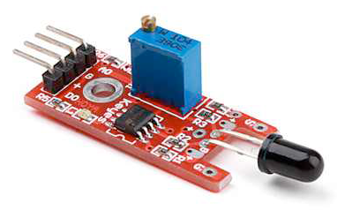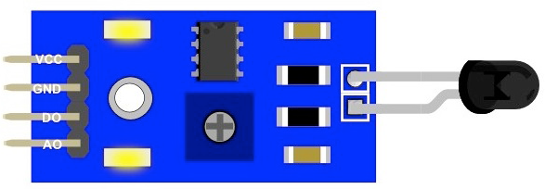

***Fig3.13. Fire Sensor***

**3.2.5 Gas Sensor**

Gas sensor is also known has Smoke sensor. Gas sensor has sensitive material of MQ-2 gas sensor is SnO2 (Tin Dioxide), which is lower conductivity in clean air. When the target combustible gas exist, The sensor’s conductivity is more higher along with the gas concentration rising. Please use simple electro circuit, Convert change of conductivity to correspond output signal of gas concentration. Good sensitivity to Combustible gas in wide range. High sensitivity to LPG, Propane and Hydrogen, Long life and low cost, Simple drive circuit are the features of Gas sensors. Domestic gas leakage detector, Industrial Combustible gas detector and Portable gas detector are the applications of Gas sensors. The Gas sensor is shown in Fig3.14.

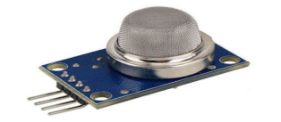

***Fig3.14. Gas Sensor***

**3.2.6 Level Sensor**

Level Sensor is also known has Magnetic Sensor. The Sensors, transducers which uses the changes in magnetic field for their operations. Level sensor is used to measure the currents, speed, position and Displacement. As the conventional sensors, Magnetic sensor does not give output parameters directly. Signal processing is required for desired output. The working of a magnetic sensor is shown in Fig3.15.

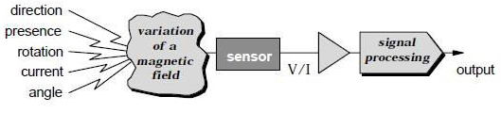

***Fig3.15. Working of Level sensor.***

On the bases of sensing the variation of magnetic fields, magnetic sensors are of three types, They are Low field sensors, Earth field sensors and BIAS Magnetic field sensors. The level sensor is shown in Fig3.16.

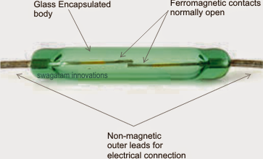

***Fig3.16. Level Sensor***

**3.2.7 PIR Sensor**

PIR sensor stands for passive infrared sensor. A passive infrared sensor (PIR sensor) is an electronic sensor that measures infrared (IR) light radiating from objects in its field of view. They are most often used in PIR based motion detectors. All objects with a temperature above absolute zero emit heat energy in the form of radiation. Usually this radiation is invisible to the human eye because it radiates at infrared wavelengths, but it can be detected by electronic devices designed for such a purpose. The term passive in this instance refers to the fact that PIR devices do not generate or radiate any energy for detection purposes. They work entirely by detecting the energy given off by other objects. PIR sensors don't detect or measure "heat"; instead they detect the infrared radiation emitted or reflected from an object. The working of a PIR sensor is shown in Fig3.17.

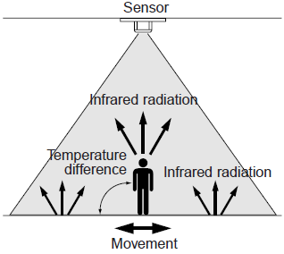

***Fig3.17. Working of PIR Sensor***

The PIR 325 Sensor is shown in Fig3.18.

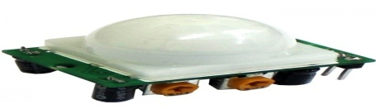

***Fig3.18. PIR 325 Sensor***

**3.2.8 IR Sensor**

IR sensor stands for infrared sensor. An infrared sensor is an electronic device, that emits in order to sense some aspects of the surroundings. An IR Sensor can measure the heat of an object as well as detects the motion. These types of sensors measures only infrared radiation, rather than emitting it that is called as a passive IR sensor. Usually in the infrared spectrum, all the objects radiate some form of thermal radiations. These types of radiations are invisible to our eyes, that can be detected by an infrared sensor. The emitter is simply an IR LED (Light Emitting Diode) and the detector is simply an IR photodiode which is sensitive to IR light of the same wavelength as that emitted by the IR LED. When IR light falls on the photodiode, The resistances and these output voltages, change in proportion to the magnitude of the IR light received. The IR Sensor is shown in Fig3.19. and Fig3.20.

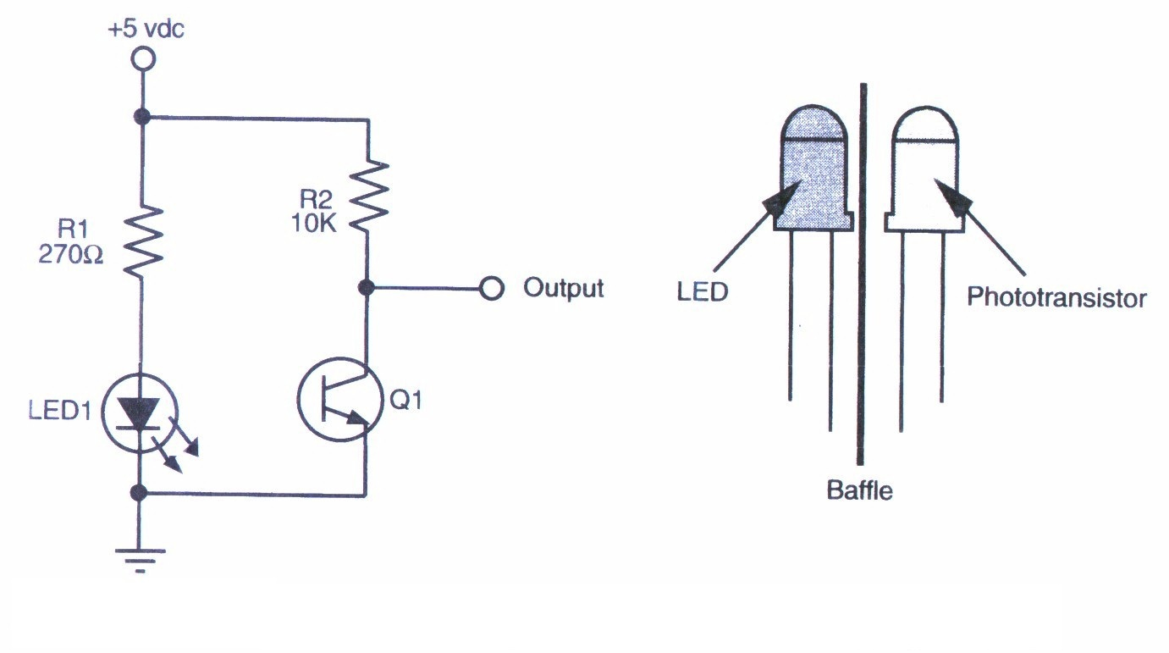

***Fig3.19. IR Sensor***

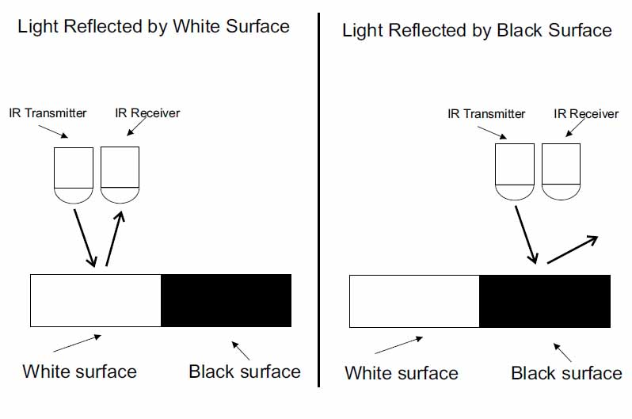

***Fig3.20. Reflected Surface Of IR Sensor***

**3.2.9 LCD Display**

LCD stands for Liquid Crystal Display.Mostly used for Display of Message. Highly user interactive. We are using 16x2 character LCD.16x2 LCD means max 16 characters per line can be displayed and there are 2 lines.Single character is displayed in 5x7 pixel matrix. 5 x 8 dots with cursor. Built in controller (KS 0066 or Equivalent). + 5V power supply (Also available for + 3V). 1/16 duty cycle. B/L to be driven by pin 1, pin 2 or pin 15, pin 16 or A.K (LED). N.V. optional for + 3V power supply. The LCD Display is shown in Fig3.21.

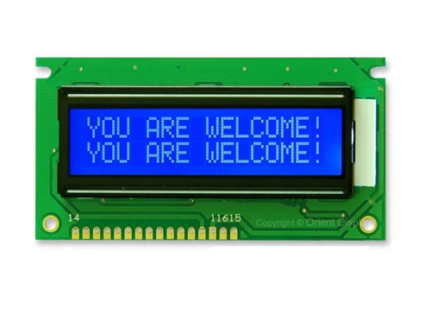

***Fig3.21. LCD Display***

**3.2.10 ULN2003 Relay Driver**

A relay is an electrically operated switch. Many relays use an electromagnet to mechanically operate a switch, but other operating principles are also used, such as solid-state relays. Relays are used where it is necessary to control a circuit by a low power signal (with complete electrical isolation between control and controlled circuits), or where several circuits must be controlled by one signal.

Relays consists of Armature, Contacts, Spring, Yoke and Coil. The first relays were used in long distance telegraph circuits as amplifiers: they repeated the signal coming in from one circuit and re-transmitted it on another circuit. Relays were used extensively in telephone exchanges and early computers to perform logical operations. The inner view of ULN2003 Relay Driver is shown in Fig3.22.

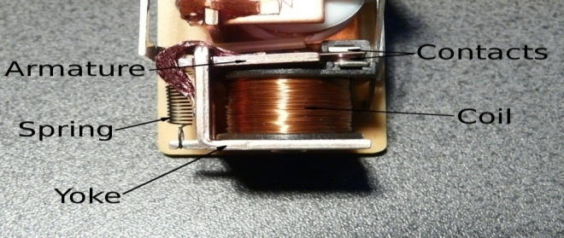

***Fig3.22. Inner View of ULN2003 Relay Driver***

The ULN2003 Relay Driver is shown in Fig3.23.

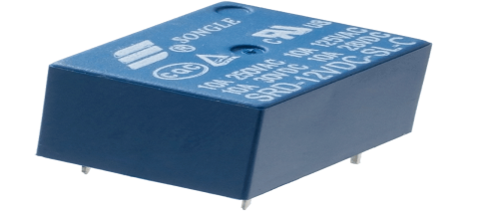

***Fig3.23. ULN2003 Relay Driver***

**3.2.11 Cooling Fan**

Cooling fan is used regulate the device temperature. To remove excess heat from the device. An automobile's cooling system is the collection of parts and substances (coolants) that work together to maintain the engine's temperature at optimal levels. Comprising many different components such as coolant, a thermostat etc. The system enables smooth and efficient functioning of the device at the same time protecting it from damage. An automotive cooling system must perform several functions

1. Remove excess heat from the device.

2. Maintain a consist device temperature.

Get the device up to optimum operating temperature as quickly as possible and maintains it at that temperature. Controls the heat produced in combustion chamber, so that the device parts are not damaged & the oil does not break down. The temperature of component must be maintained within certain limit in order to obtain maximum performance of device. Adequate cooling is then a fundamental requirement associated with reciprocating I.C.device. The fan is mounted on the impeller spindle driven by a suitable belt pulley arrangement . Fan draws air through the radiator at low speeds. The cooling fan is shown in a Fig3.24.

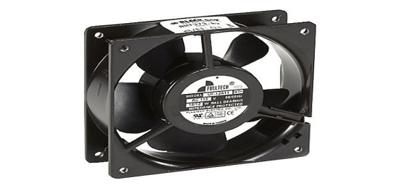

***Fig3.24. Cooling Fan***

**3.2.12 Personal Computer**

A personal computer (PC) is any general-purpose computer whose size, capabilities, and original sales price make it useful for individuals. Which is intended to be operated directly by an end user, with no intervening computer operator. May be a desktop computer, a laptop, tablet PC a handheld PC (also called palmtop) or an Apple Mac or itouch type product. *Word processing* programs are used to type, correct, rearrange, or delete text in letters, memos, reports, and school assignments. *Spreadsheet programs* enable individuals to prepare tables easily. The users of such programs establish rules for handling large groups of numbers. *Database programs* allow a computer to store large amounts of data (information) in a systematic way. *Communication programs* connect a personal computer to other computers. People can thereby exchange information with one another via their personal computers. Other programs include recreational and educational programs for playing games, composing and hearing music, and learning a variety of subjects. Delete text in letters, memos, reports, and school assignments. The Personal Computer is shown in Fig3.25.

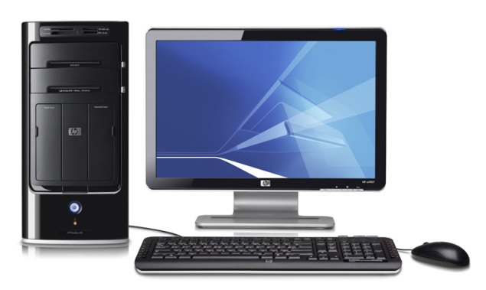

***Fig3.25. Personal Computer***

**3.2.13 L293D Motor Driver**

The L293 and L293D are quadruple high-current half-H drivers. The L293 is designed to provide bidirectional drive currents of up to 1 A at voltages from 4.5 V to 36 V. The L293D is designed to provide bidirectional drive currents of up to 600-mA at voltages from 4.5 V to 36 V. L293 is quadruple half-H driver i.e. in L293 all four input- output lines are independent. Output current per channel = 1A for L293. Hence, heat sink is provided in L293. Protective Diodes against back EMF are provided internally in L293D.To control motor speed we can use pulse width modulation (PWM), applied to the enable pins of L293 driver. PWM is the scheme in which the duty cycle of a square wave output from the microcontroller is varied to provide a varying average DC output. What actually happens by applying a PWM pulse is that the motor is switched ON and OFF at a given frequency. In this way, the motor reacts to the time average of the power supply . Speed control of L293D Motor Driver is shown in Fig3.26.

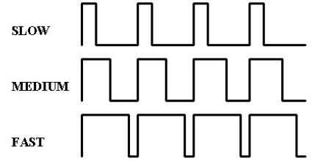

***Fig3.26. Speed control of L293D Motor Driver.***

L293D Motor Driver Block Diagram is shown in Fig3.27.

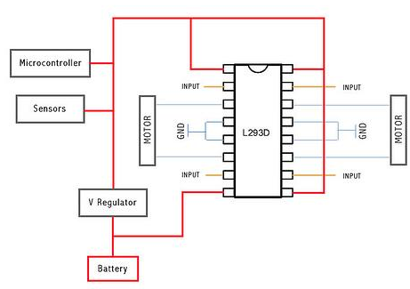

***Fig3.27 L293D Motor Driver Block Diagram***

L293D Motor Driver Pin Diagram is shown in Fig3.28.

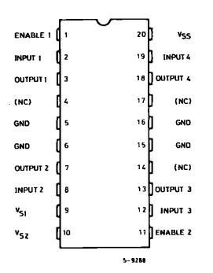

***Fig3.28 L293D Motor Driver Pin Diagram***

**3.2.14 DC Motor**

It is a low cost DC motor suitable for most robotic and general applications. It has a output shaft with a hole for easy mounting of wheels or pulleys. DC motor input voltage is 6-12 V. DC motor Stall Current is 500 - 600 mA. DC motor shaft length is 2.4 cm. DC Motor has100 rpm (rotation per minute). DC Motor is shown in Fig 3.29.

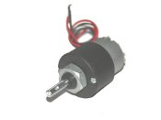

***Fig3.29 DC Motor***

Principle of DC Motor iswhen current carrying conductor is placed in a magnetic field it experience a force. Principle of operation of DC Motor is shown in Fig3.30.

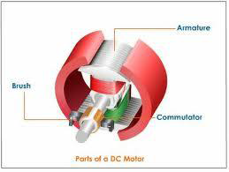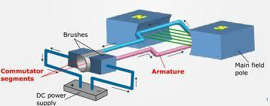

***Fig3.30 Principle of operation of DC Motor***

**3.2.15 Voltage Regulator (7805)**

7805 is a voltage regulator integrated circuit. The voltage regulator IC maintains the output voltage at a constant value. It provides +5V regulated power supply. Two basic categories of voltage regulation are:

1. line regulation

2. load regulation

**1. line regulation:** The purpose of line regulation is to maintain a nearly constant output

voltage when the input voltage varies.

**2. load regulation :** The purpose of load regulation is to maintain a nearly constant

output voltage when the load varies. The pin diagram of 7805 Voltage Regulator

is shown in Fig3.31.

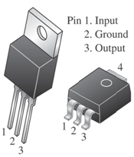

***Fig3.31 Pin Diagram Of 7805 Voltage Regulator.***

The connection diagram of 7805 Voltage Regulator is shown in Fig3.32.

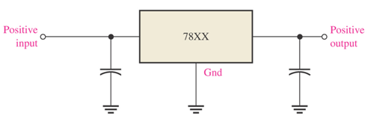

***Fig3.32 Connection Diagram Of 7805 Voltage Regulator.***

**3.2.16 Buzzer**

The buzzer is an output transducers converting electrical energy to sound. A buzzer is a signalling device, usually electronic, typically used in automobiles, household appliances, industrial appliances. They contain an internal oscillator to produce the sound which is set at about 400Hz for buzzers. Buzzers have a voltage rating but it is only approximate, for example 6V and 12V buzzers can be used with a 9V supply. Their typical current is about 25mA. Buzzers must be connected the right way round, their red lead is positive (+). The buzzer circuit diagram is shown in Fig3.33.

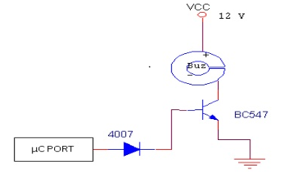

***Fig3.33 Circuit Diagram Of Buzzer***

The buzzer is shown in Fig3.34.

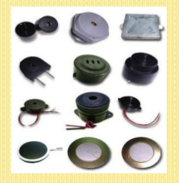

***Fig3.34 Buzzer***

**CHAPTER 4**

**SOFTWARE TOOLS**

In this Project mainly Focusing on Three Software Tools are Used. They are

1. Keiluv4 IDE Tool

2. Proteus_v7.8i

3. HyperTerminal

4. Flash Magic

5. Embedded C Language

**4.1 Keiluv4 IDE Tool:**

Keil software is the leading vendor for 8/16-bit development tools (ranked at first position in the 2004 embedded market study of the embedded system and EE times magazine).Keil software is represented worldwide in more than 40 countries, since the market introduction in 1988; the Keil compiler is the de facto industry standard and supports more than 500 current arm device variants.

Now, Keil software offers development tools for ARM. Therefore, it is possible for the results of one problem to have an effect on the next one. To avoid this possibility, it is a good idea to issue a clear command at the start of each new independent calculation.

**4.1.1 Significance of Keil Software:**

* Nine basic data types, including 32-bit IEEE floating-point.
* Flexible variable allocation with bit, data, bdata, idata, data, and p_data memory types.
* Interrupt functions may be written in C.
* Full use of the arm registers banks.
* Complete symbol and type information for source-level debugging.
* Use of AJMP and ACALL instructions.
* Bit-addressable data objects.
* This is free software (evaluation version) which solves many of the pain points for an embedded system developer.
* This software is an Integrated Development Environment(IDE), which integrated text editor to write program, a compiler and it will convert your source code into HEX file.

Here is simple guide to start working with Keil µVision which can be used for:

* Writing programs in C/C++ or Assembly.
* Compiling and assembling programs.
* Debugging programs.
* Creating HEX, AXF and BIN file.
* Test program without real hardware.

Here is step by step guide to create fresh new project for ARM7 LPC2148 Microcontroller using MDK-ARM µVision4.

* Once we’ve installed Keil, click on Keil µVision4 icon. This will appear on desktop after installation Keil.
* Click on **Project** menu, and then hit on **New µVision Project.**

[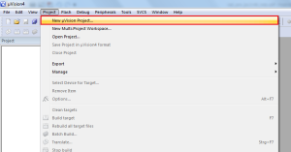](http://www.binaryupdates.com/wp-content/uploads/create_new_project_keil_lpc21481.png)

***Fig4.1 Create New Project Keil LPC2148***

* Create new project folder named as **Blinky**.

[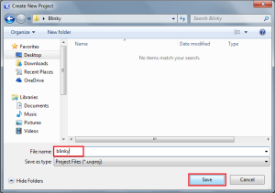](http://www.binaryupdates.com/wp-content/uploads/give_name_to_new_keil_project1.png)***Fig4.2 Create new project folder named as Blinky.***

Give Name to New Keil Project

* Select target Device vendor. In this case NXP (founded by Phillips)

[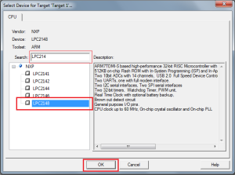](http://www.binaryupdates.com/wp-content/uploads/select_device_in_keil1.png)

***Fig4.3 Select target device vendor***

Select Device in Keil

* Expand NXP icon and select specific chip i.e. LPC2148 After this, a dialog box will pop-up on screen. This will ask you whether to copy startup code for LPC2148. Click on **Yes**.

[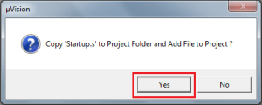](http://www.binaryupdates.com/wp-content/uploads/add_startup_file_lpc21481.png)

***Fig4.4 Add Startup File for LPC2148***

Add Startup File for LPC2148

* Then we’ll get basic workplace to get start with writing code in. When we expand **Target1** in left project pane. We see **Startup's** is already added which is necessary for running code in Keil.

[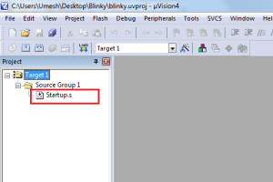](http://www.binaryupdates.com/wp-content/uploads/ready_workplace_for_lpc21481.png)

***Fig4.5 Ready Workplace For LPC2148***

**NOTE:**

Code will not run without Startup's file. Because startup code executes immediately upon reset of the target system and performs the following listed operations.

1. Defines interrupt and exception vectors

2. Configures the CPU clock source (on same device)

3. Initializes the external bus controller

4. Copies the exception vectors from ROM and RAM for systems with memory

remapping

5. Initializes other low level peripherals, if necessary

6. Reserves and initializes the stack for all modes

7. Reserves the heap

8. Transfers control to the main C function

* Now click on **File** menu and hit on **New**.

[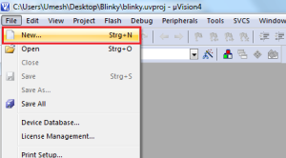](http://www.binaryupdates.com/wp-content/uploads/create_new_file_keil1.png)

***Fig4.6 Create New File Keil***

* Write code to blink LED in C and FileName.c **Save**. NOTE: Don’t forget to save as with .c extension

[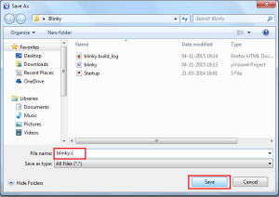](http://www.binaryupdates.com/wp-content/uploads/add_c_file_to_keil_project1.png)

***Fig4.7 Add C File To Keil Project***

* Once we save file as **blinky.c**. We’ll quickly get complete code with syntax highlighted.

[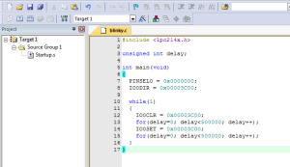](http://www.binaryupdates.com/wp-content/uploads/code_highlighted_in_keil_lpc21481.png)

***Fig4.8 Code Highlighted In Keil LPC2148***

* Now we can add blinky.c file by adding it to **Group Source 1**.

[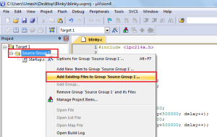](http://www.binaryupdates.com/wp-content/uploads/add_source_file_to_project_lpc21481.png)

***Fig4.9 Add Source File To Project LPC2148***

* Add **blinky.c** file

[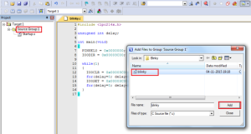](http://www.binaryupdates.com/wp-content/uploads/add_file_to_keil_project1.png)

***Fig4.10 Add File To Keil Project***

* Now right click on **Target 1** and hit on **Options for target “Target 1”**

[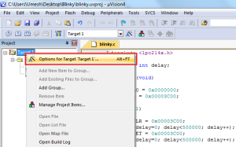](http://www.binaryupdates.com/wp-content/uploads/set_options_for-_target_lpc21481.png)

***Fig4.11Set Options For Target LPC2148***

* In **Options for target “Target 1”**. In **output** tab, click on check box **Create HEX File**.

[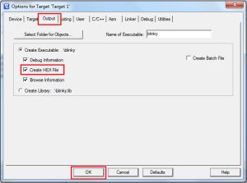](http://www.binaryupdates.com/wp-content/uploads/set_output_keil_lpc21481.png)

***Fig4.12 Set Output Keil LPC2148***

* Then go to Linker tab. Click on **Use Memory Layout for Target Dialog**

[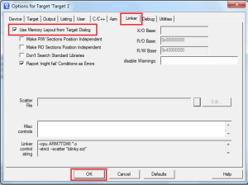](http://www.binaryupdates.com/wp-content/uploads/setup_linker_option_keil_lpc21481.png)

***Fig4.13Setup Linker Option Keil LPC2148***

* Then hit on **Rebuild** All target files

[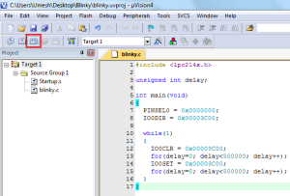](http://www.binaryupdates.com/wp-content/uploads/rebuild_the_keil_project_lpc21481.png)

***Fig4.14 Setup Linker Option Keil LPC2148 with code.***

* Now we can see Build output. If we check project directory at this point. We’ll find generated HEX file. Later on we’ll use it to load or burn into LPC2148 MCU using Flash Magic.

[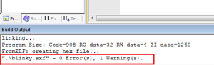](http://www.binaryupdates.com/wp-content/uploads/build_output_keil_lpc21481.png)

***Fig4.15 Build Output Keil LPC2148***

[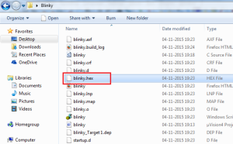](http://www.binaryupdates.com/wp-content/uploads/hex_file_generated_keil_lpc21481.png)

***Fig4.16 HEX File Generated Using Keil LPC2148***

**4.2. Proteus_v7.8i:**

The Proteus Design Suite is an Electronic Design Automation (EDA) tool including schematic capture, simulation and PCB Layout modules. The Proteus Design Suite is the tool used for simulation before executing the code in a circuit board because of safety of a kit. It is developed in Yorkshire, England by Lab center Electronics Ltd with offices in North America and several overseas sales channels. The software runs on the Windows operating system and is available in English, French, Spanish and Chinese languages. The Proteus Design Suit downloading from the site is shown in Fig4.17.

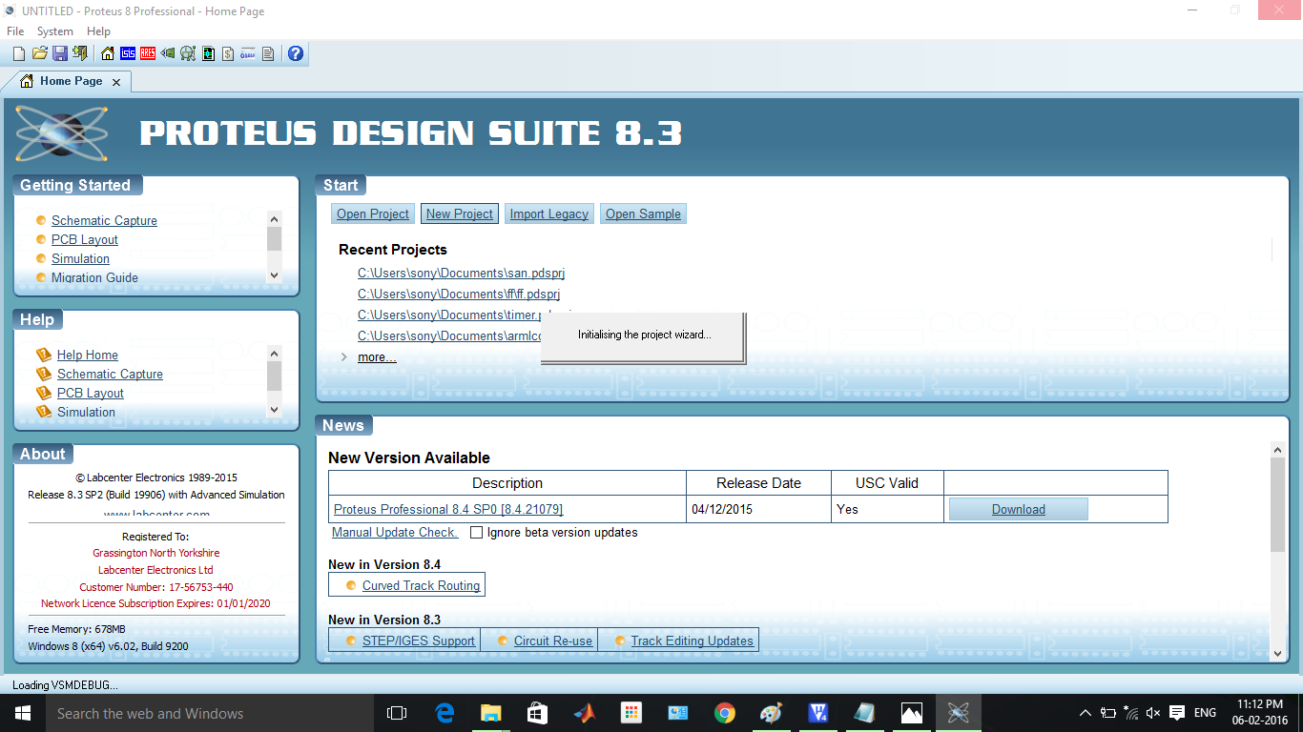

***Fig4.17 The Proteus Design Suit downloading from the site.***

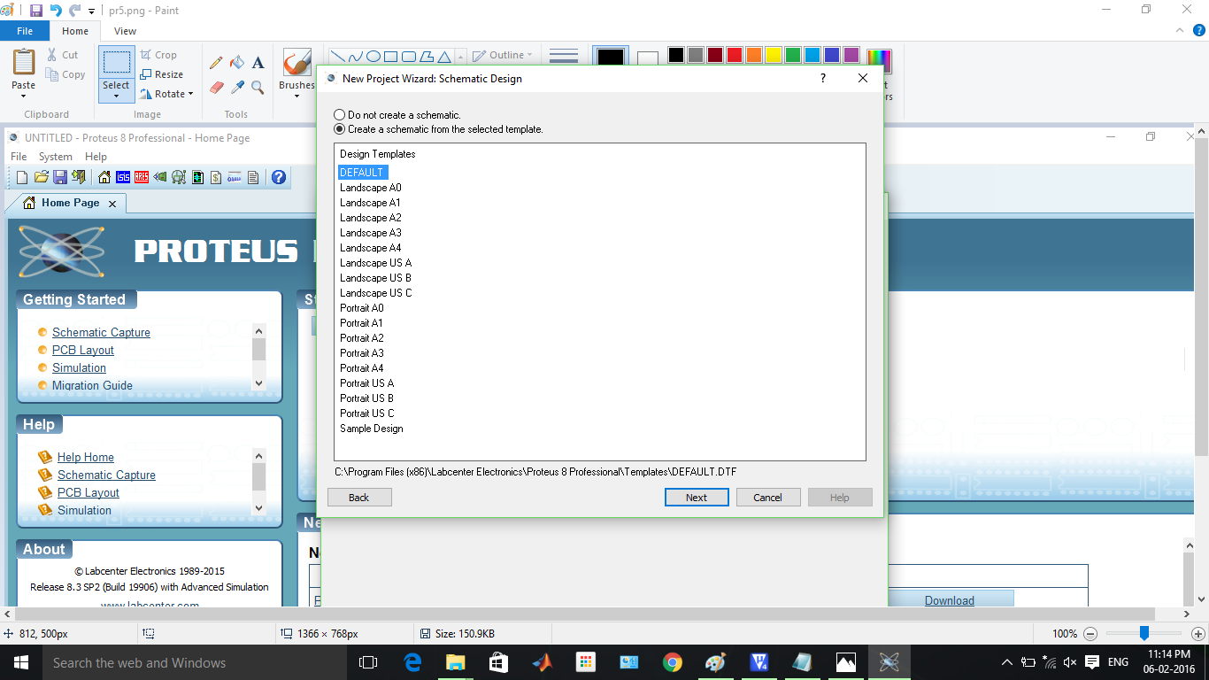

***Fig4.18 The Proteus Design Suit for creating the new project.***

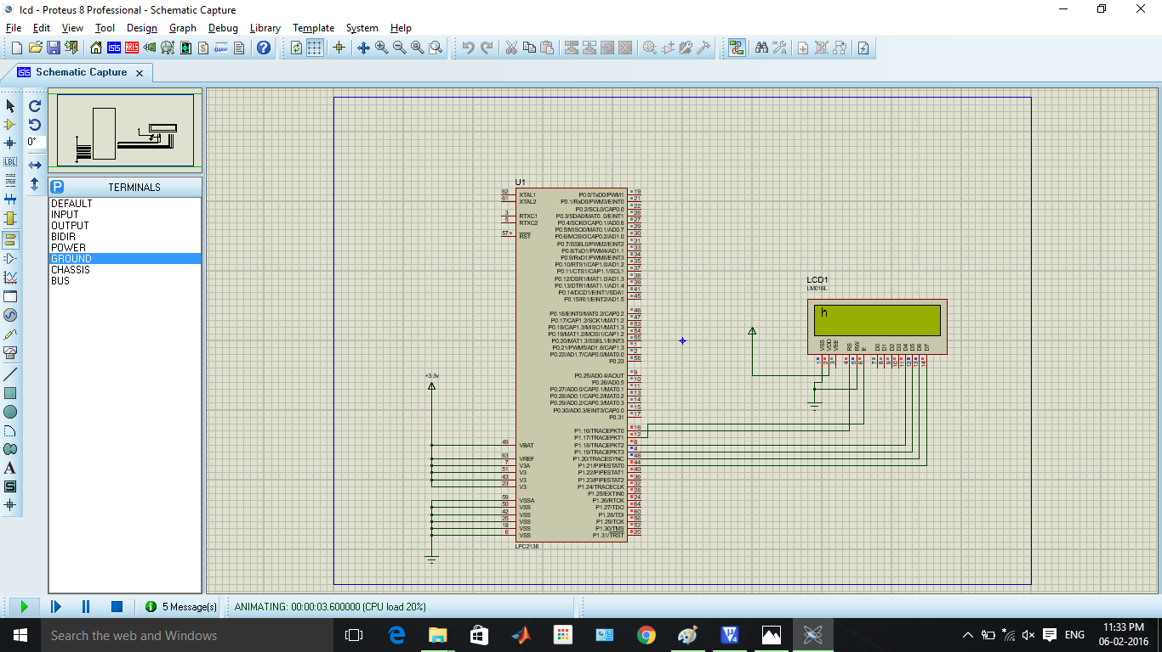

***Fig4.19 The Proteus Design Suit For Schematic Capture.***

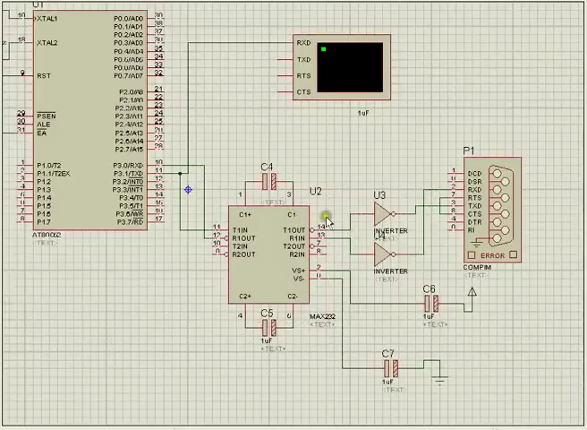

***Fig4.20 Schematic Capture By Proteus Design.***

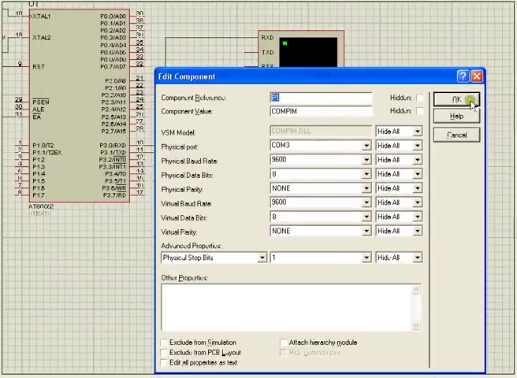

***Fig4.21 Edit Components Of Proposed System By Proteus Design.***

**4.3 HyperTerminal:**

HyperTerminal is also known as HyperAccess. HyperTerminal is used to show the output in a personal computer with the help of ZigBee. HyperAccess is a family of terminal emulation software by Hilgraeve. A version of HyperAccess, called HyperTerminal is included in some versions of Windows.

It was the first software product from Hilgraeve, and it was initially designed to let 8-bit [Heath](https://en.wikipedia.org/wiki/Heathkit) computers communicate over a modem. In 1985, this same product was ported to [IBM PCs](https://en.wikipedia.org/wiki/IBM_PC) and compatible systems, as well as Heath/Zenith's [Z-100](https://en.wikipedia.org/wiki/Zenith_Z-100) non-PC-compatible [MS-DOS](https://en.wikipedia.org/wiki/MS-DOS) computer. Over the years, the same version of this technology would be ported to other operating systems, including [OS/2](https://en.wikipedia.org/wiki/OS/2), [Windows 95](https://en.wikipedia.org/wiki/Windows_95) and [Windows NT](https://en.wikipedia.org/wiki/Windows_NT). It has earned a total of five Editor's Choice awards from [PC Magazine](https://en.wikipedia.org/wiki/PC_Magazine).

In 1995, Hilgraeve licensed a low-end version of HyperAccess, known as HyperTerminal, to [Microsoft](https://en.wikipedia.org/wiki/Microsoft) for use in their set of communications utilities. It was bundled with [Windows 95](https://en.wikipedia.org/wiki/Windows_95) through [Windows XP](https://en.wikipedia.org/wiki/Windows_XP), but no longer bundled with [Windows Vista](https://en.wikipedia.org/wiki/Windows_Vista), [Windows 7](https://en.wikipedia.org/wiki/Windows_7), [Windows 8](https://en.wikipedia.org/wiki/Windows_8), or later Windows.

The commercial products, HyperTerminal Private Edition and HyperAccess, both support all versions of Windows up to and including [Windows 10](https://en.wikipedia.org/wiki/Windows_10).

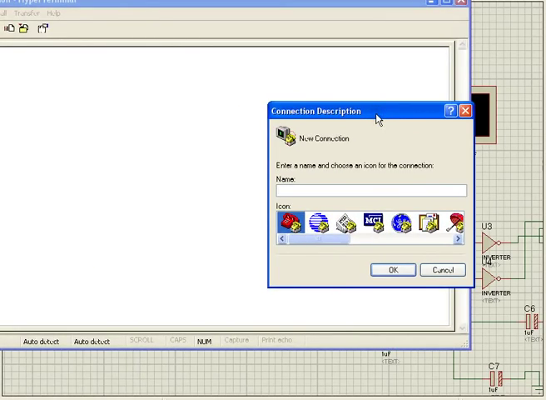

***Fig4.22 New Connection For Displaying The Code In A System By Assigning Name And Icon***

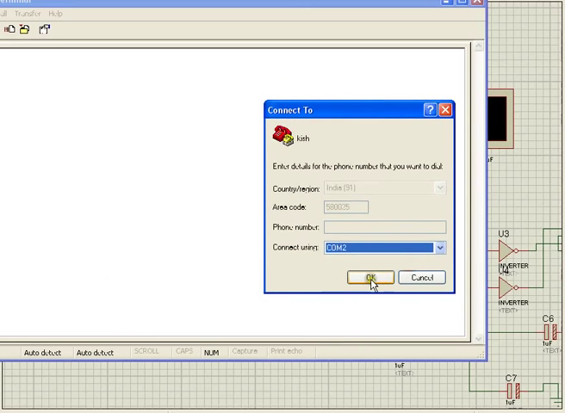

***Fig4.23 Connection Using COM2 Port***

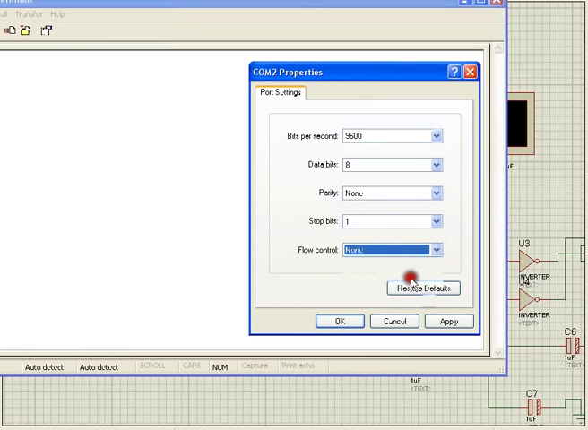

***Fig4.24 COM2 Properties***

Note: Select bits per second to 9600, Data bits has 8, Parity has None, Stop bits has 1, Flow control has None and press OK button.

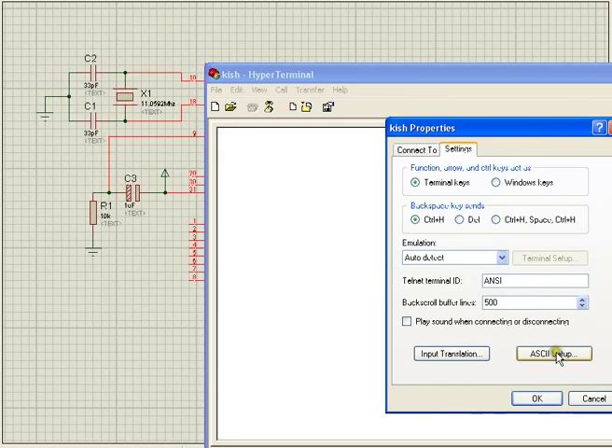

***Fig4.25 File Properties Settings***

Note: Open file and select file properties and go to settings and select ASCII Setup.

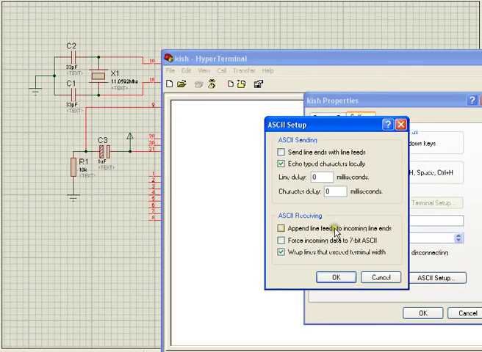

***Fig4.26 ASCII Setup***

Note: Check the mark of "Echo typed characters locally" and press OK button.

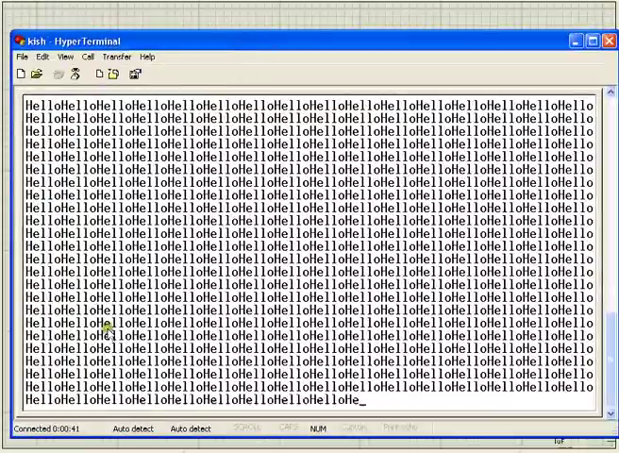

***Fig4.27 Message Displayed In HyperTerminal***

**4.4. Flash Magic:**

The Flash Magic is an affordable, reliable, and fast programmer for LPC 2148 Microcontrollers and 24Cxx I2C EEPROMs. This Flash Magic tool is used to dump the code into a device. The programmer is designed to operate with the Intel Pentium-based IBM- compatible desktop computers. The menu-driven software interface makes it easy to operate.

Easy to use integrated HEX Editor on main software window, Supports Intel (linear & segmented) HEX (INHX8M). Auto Batch Program function for faster programming i.e. Mass Production mode. Automatic device identification before programming. Support for programming only a selected memory in the microcontroller. e.g. Data memory or Fuse Bits.

The only part left here is to setup Flash Magic and load HEX file into LPC2148 Microcontroller. Here are some pictures or I recommend you to watch video on this post to see step by step configuration and final output.

[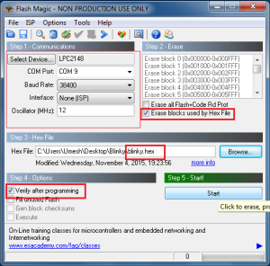](http://www.binaryupdates.com/wp-content/uploads/basic_setting_flashmagic_lpc21481.png)

***Fig4.28 Basic Setting Flash Magic LPC2148***

STEP-2

[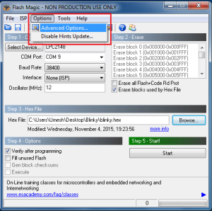](http://www.binaryupdates.com/wp-content/uploads/setup_options-for_flashmagic_lpc21481.png)

***Fig4.29 Setup Options For Flash Magic LPC2148***

STEP-3

[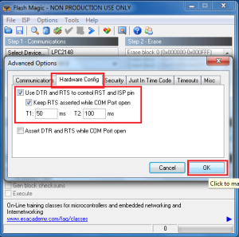](http://www.binaryupdates.com/wp-content/uploads/setup_hardware_configuration_flashmagic1.png)

***Fig4.30 Setup Hardware Configuration FlashMagic***

STEP-4 Finally It’s Done….!!!!

[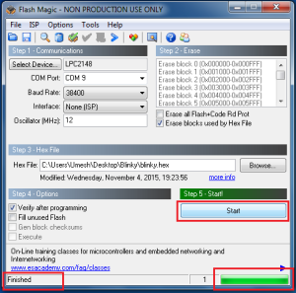](http://www.binaryupdates.com/wp-content/uploads/flashmagic_loading_finished_lpc21481.png)

***Fig4.31 FlashMagic Loading Finished LPC2148***

**4.5 Embedded C Programming**

Embedded C is a set of language extensions for the [C Programming language](https://en.wikipedia.org/wiki/C_Language) by the [C Standards committee](https://en.wikipedia.org/wiki/SC22) to address commonality issues that exist between C extensions for different [embedded systems](https://en.wikipedia.org/wiki/Embedded_systems). Historically, embedded C programming requires nonstandard extensions to the C language in order to support exotic features such as [fixed-point arithmetic](https://en.wikipedia.org/wiki/Fixed-point_arithmetic), multiple distinct [memory banks](https://en.wikipedia.org/wiki/Memory_bank), and basic [I/O](https://en.wikipedia.org/wiki/Input/output) operations.

In 2008, the C Standards Committee extended the C language to address these issues by providing a common standard for all implementations to adhere to. It includes a number of features not available in normal C, such as, fixed-point arithmetic, named address spaces, and basic I/O hardware addressing.

Embedded C uses most of the syntax and semantics of standard C, e.g., main() function, variable definition, data type declaration, conditional statements (if, switch, case), loops (while, for), functions, arrays and strings, structures and union, bit operations, macros, etc.

The main ( ) function is indeed the main function.There are other practices that characterize embedded C development:

* In-line assembly language.
* Device knowledge.
* Mechanical knowledge.

**Flowchart to Embedded C:**

When designing embedded hardware you probably want to visually express what embedded software will be performing and how different functions depend on each other? How to make software documentation simple clear and informative. If you are developer, you may want to explain your ideas understandably without loads of code text. So depending on what level information has to be provided you may choose any of following. Now we can add some concrete information to the flowchart for the algorithm. This in turn will help us lay out our source files.

Data flow diagrams are used when you need to see the processes and what data is transferred between different functions. This way each process or function is expressed as block (or any other shape) while lines shows what information passes between processes. As you can see in example figure simple data flow diagram is presented. Without program code it is easy to read how program operates.

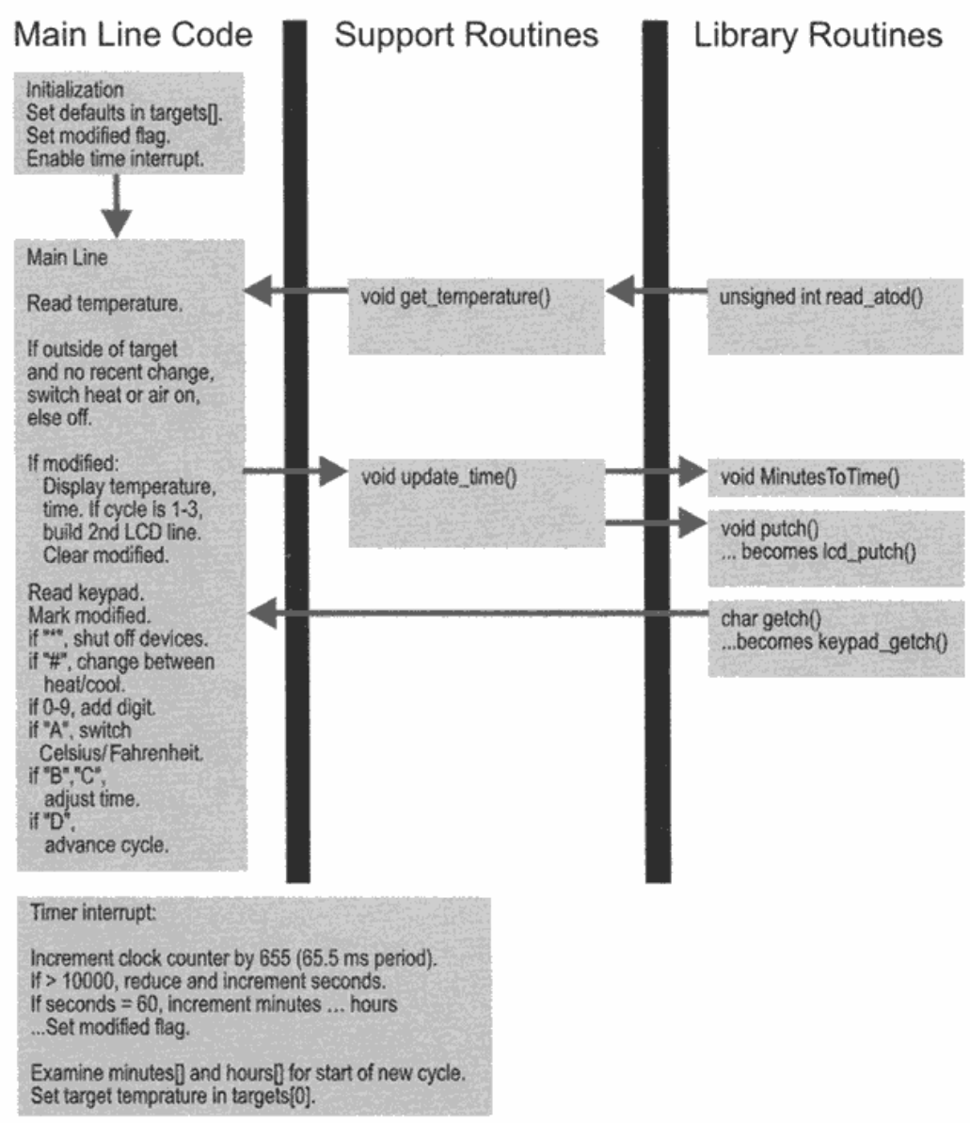

***Fig.4.32.Embedded C Flowchart***

**4.6 PROGRAM (Keil Code)**

#include<lpc214x.h>

#include<string.h>

#define CZ 0x1A

#define CR 0x0D

#define LF 0x0A

#define DQ 0x22

#define BUZZER_ON() IO0SET

#define BUZZER_OFF() IO0CLR

#define COMMAND_PORT()

#define EN_LOW() IO1CLR

#define OBS (0x00080000)

#define alc (0x00800000)

#define fir (0x00200000)

#define pir (0x00000020)

#define level1 (0x00010000)

#define level2 (0x00020000)

#define level3 (0x00040000)

#define DATA_PORT() IO1SET

#define EN_HI() IO1SET

#define FAN_ON() IO0SET

//Macro Functions to turn ON Buzzer

#define FAN_OFF() IO0CLR

#define MOTOR_ON() IO0SET

#define MOTOR_ON1() IO0SET

#define MOTOR_ON2() IO0SET

#define MOTOR_ON3() IO0SET

#define MOTOR_OFF() IO0CLR

#define MOTOR_OFF1() IO0CLR

#define MOTOR_OFF2() IO0CLR

#define MOTOR_OFF3() IO0CLR

unsigned char b[80];

unsigned char si,sf;

unsigned char r,j1;

void send_sms(unsigned char *msg,unsigned char *num);

unsigned char strg1cmp(unsigned char [],unsigned char []);

void UART1_SendStr(const unsigned char);

void UART1_SendByte(unsigned char data);

void UART0_SendStr(const unsigned char);

void UART0_SendByte(unsigned char data);

void Delay(unsigned int);

void LCD_Command(unsigned int);

void LCD_Data(unsigned int);

void LCD_Init(void);

void conv(unsigned int );

void LCD_String(unsigned char *);

void Delay_Ticks(unsigned int);

void Init_UART0(void);

void Init_UART1(void);

char inp0(char _bit);

void clearrx(void);

unsigned char receive( void );

unsigned char Count=00;

unsigned int h1=0,h2=0;

unsigned char dat1='\0';

void isr (void) __irq

{

unsigned char ch;

if(0x00000080)

{

if(U1LSR)

{

ch=U1RBR;

b[i++];

}

b[i]='0';

VicVectAddr = 0x00000000;

}

}

int main(void)

{

PINSEL0 = 0x00050005;

PINSEL1 = 0x00000000;

PINSEL2 = 0x00000000;

Delay(100);

IO1DIR = 0x03FF0000;

IO0DIR = 0x0000FC00;

LCD_Init();

Init_UART0();

Init_UART1();

U1IER=0x01;

VicIntEnClr = 0xffffffff;

VicIntSelect= 0x00000000;

VicVectCntl0 = 0x2017;

VicVectAddr0 = (unsigned long );

VicIntEnable = 0x80;

LCD_Command(0x01);

Delay(100);

IO0CLR=0x00000010;

LCD_Command(0x80);

LCD_String("WIRELESS BASED ");

LCD_Command(0xC0);

LCD_String("INDUSTRIAL APPLICATIONS");

Delay(200);

LCD_Command(0x01);

UART0_SendStr("\n\r WSN based Mobile Control Room");

UART0_SendStr("\n\r Environment for Industrial Applications\n\r");

LCD_Command(0x80);

UART1_SendStr("AT");

UART1_SendByte(CR);

UART1_SendByte(LF);

UART1_SendStr("AT+IPR=9600");

UART1_SendByte(CR);

UART1_SendByte(LF);

Delay_Ticks(100);

LCD_Command(0x80);

send_sms("MOVING......... ","+919490076150");

UART0_SendStr("\n\rMOVING........");

Delay(50000);

IO0SET=(1<<11);

IO0CLR=(1<<12);

IO0SET=(1<<13);

IO0CLR=(1<<15);

IO0CLR=(1<<14);

while(1)

{

dat1=receive();

Delay_Ticks(50);

si=inp0(4);

LCD_Command(0x80);

if((IO0PIN) ==0)

{

LCD_Command(0x80);

send_sms ("SMOKE DETECTED ","+919490076150");

LCD_String ("SMOKE DETECTED ");

UART0_SendStr("\n\r SMOKE DETECTED FAN ON \n\r");

BUZZER_ON();

IO0CLR = (1<<11);

IO0CLR = (1<<12);

IO0CLR = (1<<13);

IO0CLR = (1<<14);

Delay(1000);

BUZZER_OFF();

}

else if(OBS== 0x00400000)

{

LCD_Command(0x80);

send_sms("OBSTACLE DETECTED PATH CHANGE

","+919490076150");

LCD_String("OBSTACLE DETECTED ");

UART0_SendStr("\n\r OBSTACLE DETECTED PATH CHANGE \n\r");

LCD_Command(0xC0);

LCD_String(" PATH CHANGE...... ");

BUZZER_ON();

IO0CLR = (1<<11);

IO0CLR = (1<<12);

IO0SET = (1<<13);

IO0CLR = (1<<14);

Delay(1000);

BUZZER_OFF();

}

else if((IO0PIN &0x00080000) ==0)

{

LCD_Command(0x80); //Cursor on first line

send_sms("FIRE DETECTED ","+919490076150");

LCD_String("FIRE DETECTED ");

UART0_SendStr("\n\r FIRE DETECTED FAN_ ON\n\r");

BUZZER_ON();

IO0CLR = (1<<11);

IO0CLR = (1<<12);

IO0CLR = (1<<13);

IO0CLR = (1<<14);

LCD_Command(0xC0);

LCD_String("FAN ON ");

FAN_ON();

Delay(1000);

BUZZER_OFF();

FAN_OFF();

}

else if(pir ==0x00000020)

{

LCD_Command(0x80);

send_sms("PERSON DETECTED ","+919490076150");

LCD_String("PERSON DETECTED ");

UART0_SendStr("\n\r PERSON DETECTED BUZZER ON \n\r");

BUZZER_ON();

IO0CLR = (1<<11);

IO0CLR = (1<<12);

IO0CLR = (1<<13);

IO0CLR = (1<<14);

Delay(1000);

BUZZER_OFF();

}

else if((IO0PIN & 0x00010000) ==0)

{

LCD_Command(0x80);

send_sms("LEVEL1 25% ","+919490076150");

UART0_SendStr("\n\r LEVEL1 25% \n\r");

LCD_String("LEVEL1 25% ");

IO0CLR = (1<<11);

IO0CLR = (1<<12);

IO0CLR = (1<<13);

IO0CLR = (1<<14);

}

else if((IO0PIN & 0x00020000) ==0)

{

LCD_Command(0x80);

send_sms("LEVEL2 50% ","+919490076150");

UART0_SendStr("\n\r LEVEL2 50% \n\r");

LCD_String("LEVEL2 50% ");

IO0CLR = (1<<11);

IO0CLR = (1<<12);

IO0CLR = (1<<13);

IO0CLR = (1<<14);

}

else if((IO0PIN & 0x00040000) ==0)

{

LCD_Command(0x80);

send_sms("LEVEL3 75% ","+919490076150");

UART0_SendStr("\n\r LEVEL3 75% \n\r");

LCD_String("LEVEL3 75% ");

BUZZER_ON();

IO0CLR = (1<<11);

IO0CLR = (1<<12);

IO0CLR = (1<<13);

IO0CLR = (1<<14);

Delay(1000);

BUZZER_OFF();

}

else

{

LCD_Command(0x80);

LCD_String(" MONITORING...>>> ");

UART0_SendStr("\n\rMONITORING .... \n");

LCD_Command(0xC0);

LCD_String(" ");

IO0CLR=(1<<15);

IO0SET=(1<<11);

IO0CLR=(1<<12);

IO0SET=(1<<13);

IO0CLR=(1<<14);

}

}

}

void Delay(unsigned int j4)

{

unsigned int i1,i2;

for(i1=0;i1<j4;i1++)

for(i2=0; i2<6000; i2++);

}

void LCD_Command(unsigned int data)

{

unsigned int temp=0;

EN_LOW();

COMMAND_PORT();

temp=data;

temp = (temp) << 18;

IO1SET= temp;

EN_HI();

EN_LOW();

IO1CLR=temp ;

Delay(10);

}

void LCD_Data(unsigned int data)

{

unsigned int temp=0;

EN_LOW();

DATA_PORT();

temp=data;

temp= (temp) << 18;

IO1SET= temp;

EN_HI();

EN_LOW();

IO1CLR= temp ;

Delay(1);

}

void LCD_Init()

{

LCD_Command(0x30);

}

void LCD_String(unsigned char *data)

{

while(*data)

{

LCD_Data(*data);

data++;

}

}

void Delay_Ticks(unsigned int Delay)

{

unsigned int mo;

for(; Delay>0; Delay--)

for(mo=0; mo<50000; mo++);

}

void Init_UART0(void)

{

unsigned int Baud16;

U0LCR = 0x83;

Baud16=(Fpclk / 16) / 9600;

U0DLM = Baud16 / 256;

U0DLL = Baud16 % 256;

U0LCR = 0x03;

}

void Init_UART1(void)

{

unsigned int Baud16;

U1LCR = 0x83;

Baud16 = (Fpclk / 16) / 9600;

U1DLM = Baud16 / 256;

U1DLL = Baud16 % 256;

U1LCR = 0x03;

}

void UART0_SendByte(unsigned char data)

{

U0THR = data;

while(!(U0LSR&0x20));

}

void UART0_SendStr(const unsigned char *str) {

while(1)

{

if( *str == '\0' ) break;

UART0_SendByte(*str++);

}

}

void UART1_SendByte(unsigned char dataso)

{

U1THR = dataso;

while(!(U1LSR&0x20));

}

void send_sms(unsigned char *msg,unsigned char *num)

{

UART1_SendStr("AT");

UART1_SendByte(CR); UART1_SendByte(LF);

Delay_Ticks(20);

UART1_SendStr("AT+CMGF=1");

UART1_SendByte(CR); UART1_SendByte(LF);

Delay_Ticks(20);

UART1_SendStr("AT+CMGS=");UART1_SendByte(DQ);UART1_SendStr(num);UART1_SendByte(DQ);

Delay_Ticks(20);

UART1_SendByte(CR); UART1_SendByte(LF);

Delay_Ticks(20);

UART1_SendStr(msg);

UART1_SendByte(CR); UART1_SendByte(LF);

Delay_Ticks(20);

UART1_SendByte(CZ);

Delay_Ticks(20);

void clearrx(void)

{

for(i=0;i<=75;i++)

b[i]='\0';

i=0;

}

**CHAPTER 5**

**RESULTS**

**5.1 Specifications of WSN based mobile and pc control room environment for industrial**

**applications:**

1. Power Supply

DC Voltage - 5V, 500mA

1. Operating Temperature - 25-75 degree/cel
2. Switching Time - 7ms
3. Releasing - 4ms
4. IR Detection Range - Up to 50 cm
5. PIR Detection Range - Up to 10 meters at an angle of ± 15 degrees.
6. Smoke/ Gas Detection Range - Concentration, small per minute.
7. Magnetic/ Level Detection Range - Up to level indications. such as 75%
8. Fire/Flame Detection Range - Ultraviolent waves up to 300nm

**5.2 Results:**

The proposed WSN system captures information and transmits it via a SMS through GSM module and PC through ZigBee module. LPC2148 Microcontroller operates and controls moving motion detectors, fire detection, gas detection, obstacle detection and level detection for remote sensing and surveillance.

For example , when moving motion is detected, The person detected text is displayed on LCD display and at the same time the text is forwarded to mobile with the help of GSM module and at the same time the text is displayed on PC. Similarly all the parameters are displayed on LCD display are send to mobile and PC.

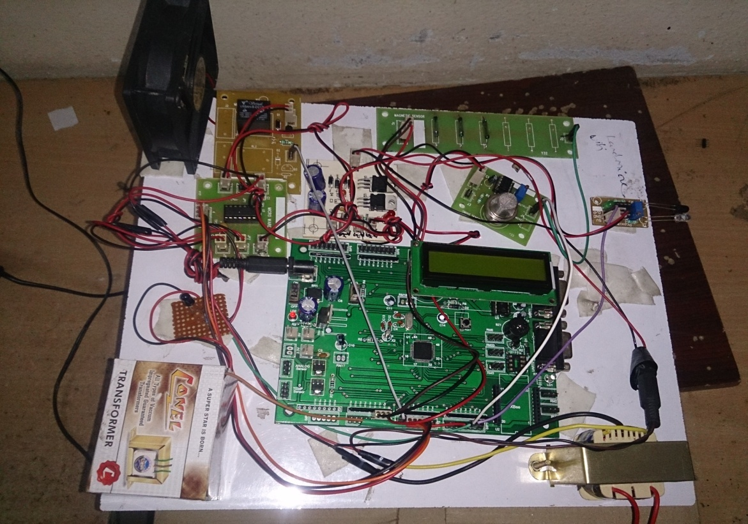

***Fig.5.2.1 Project without power ON***

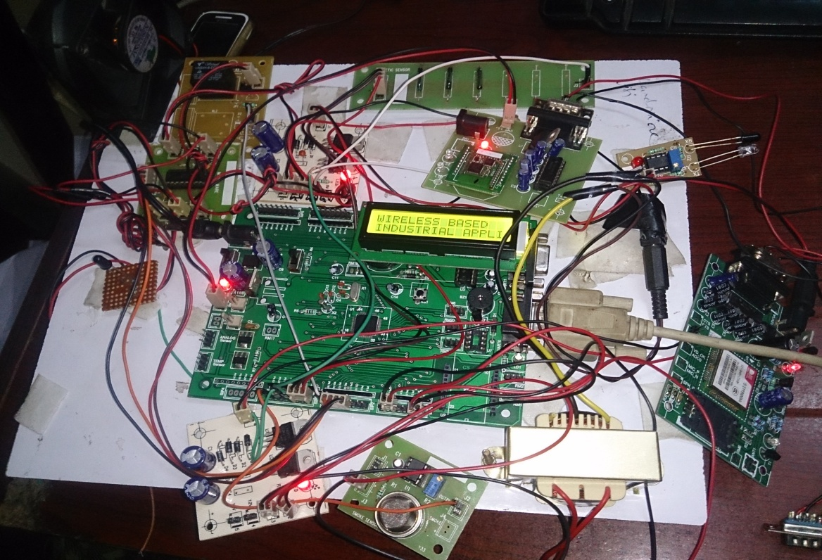

***Fig.5.2.2 Project with title***

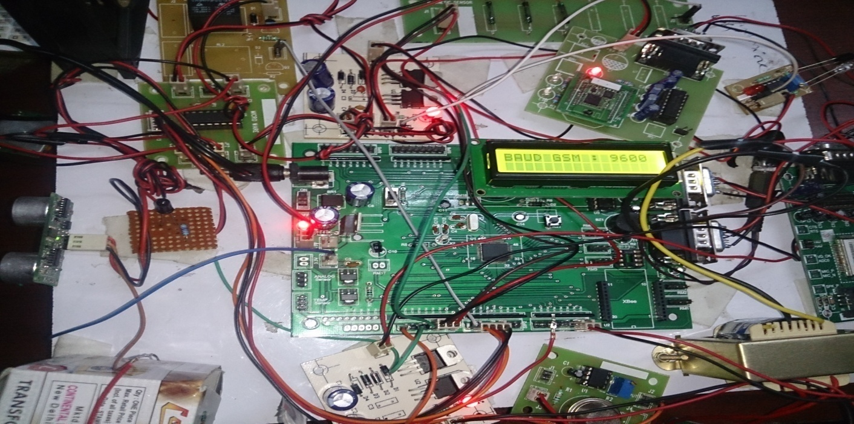

***Fig.5.2.3 BAUD GSM : 9600***

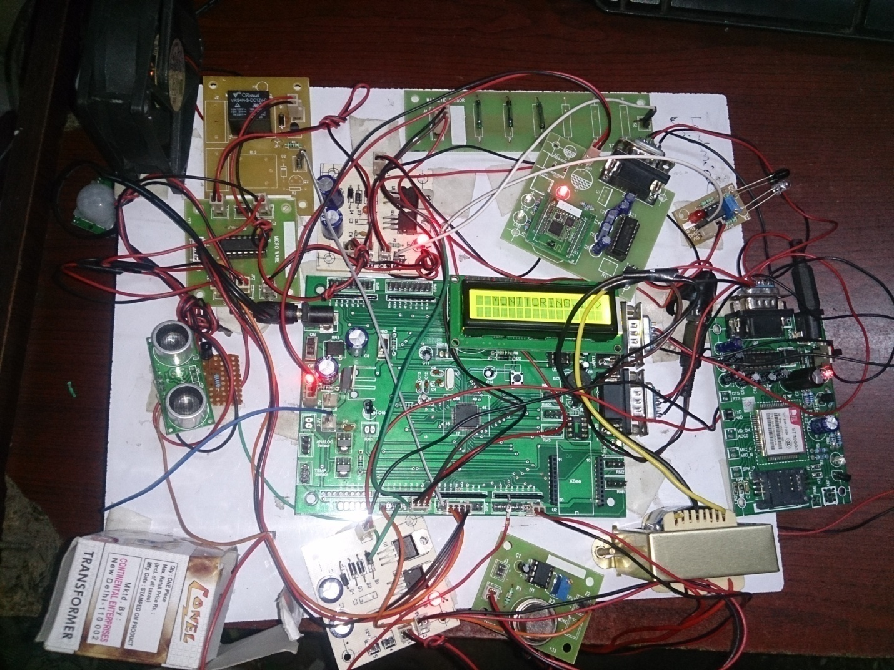

***Fig.5.2.4 MONITORING***

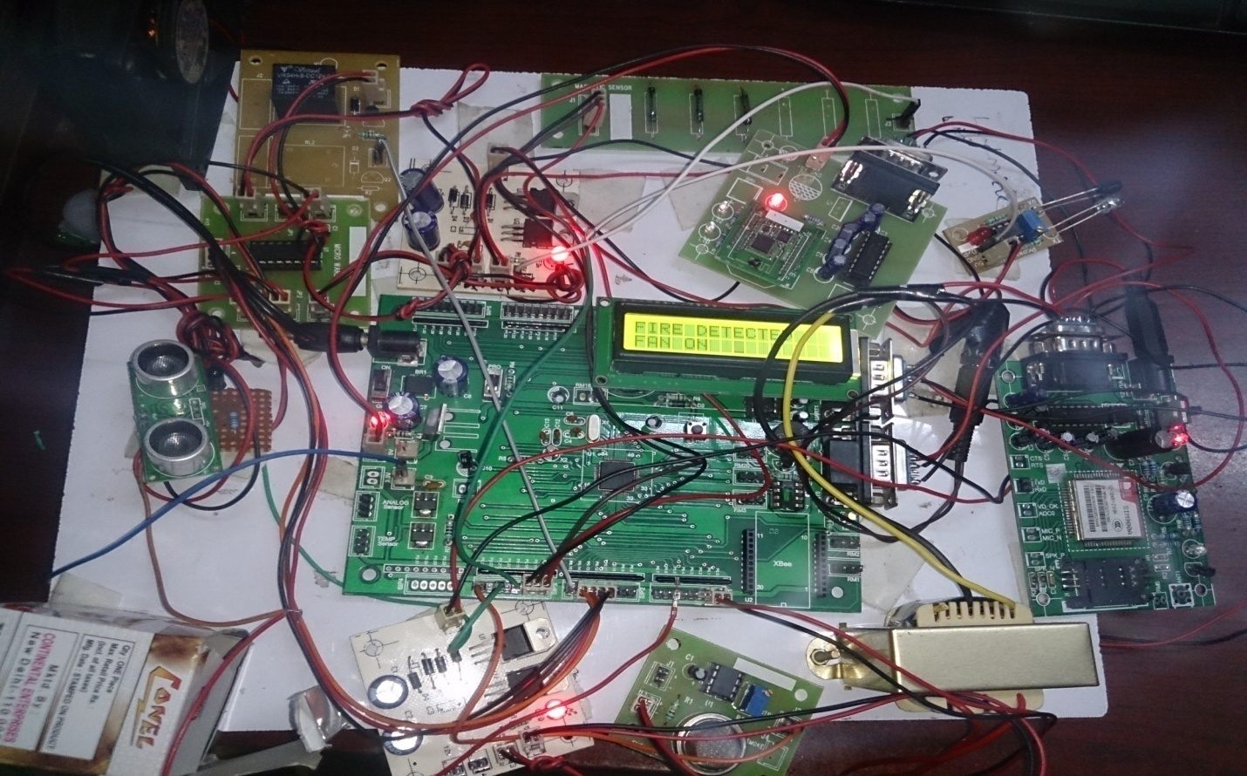

***Fig.5.2.5 FIRE DETECTED: FAN ON***

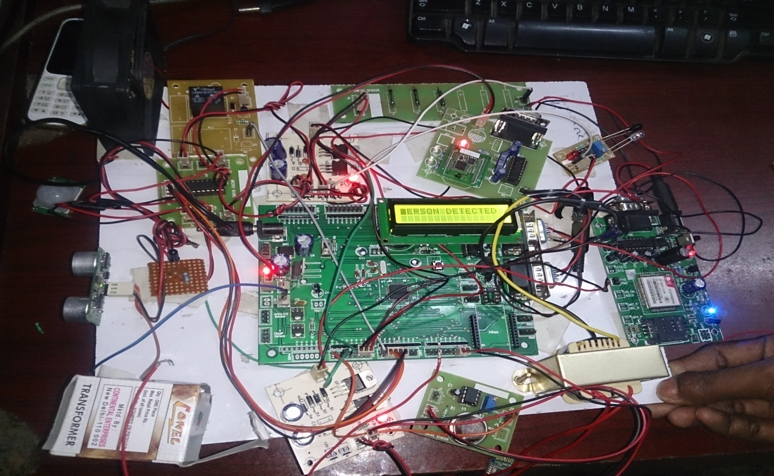

***Fig.5.2.6 PERSON DETECTED***

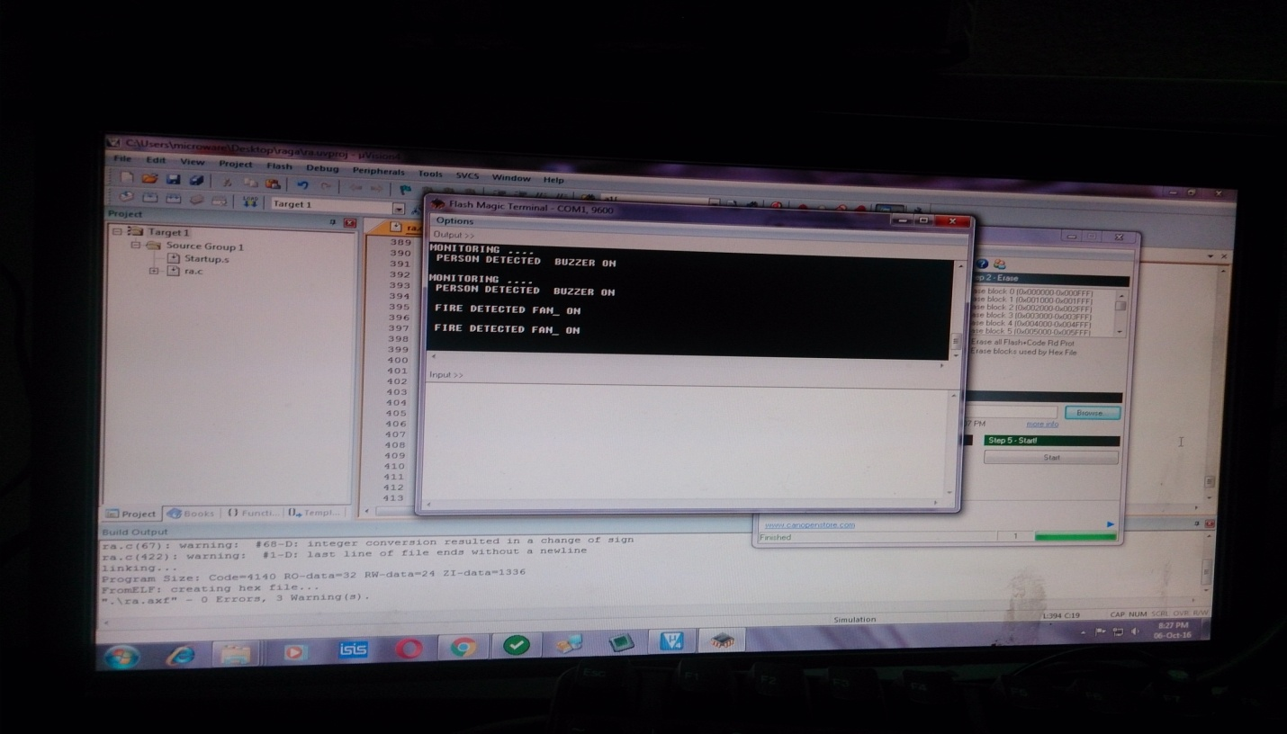

***Fig.5.2.7 Fire Detected Fan On, Person Detected Buzzer On SYSTEM***

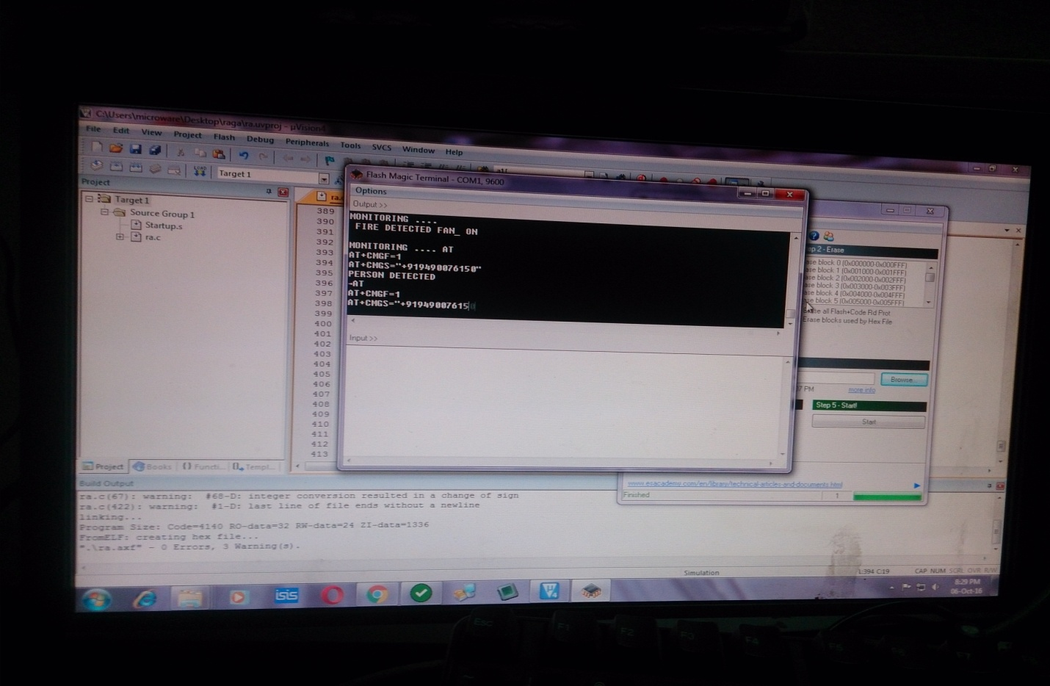

***Fig.5.2.8 Fire Detected Fan On, Person Detected Buzzer On SYSTEM With AT Commands GSM***

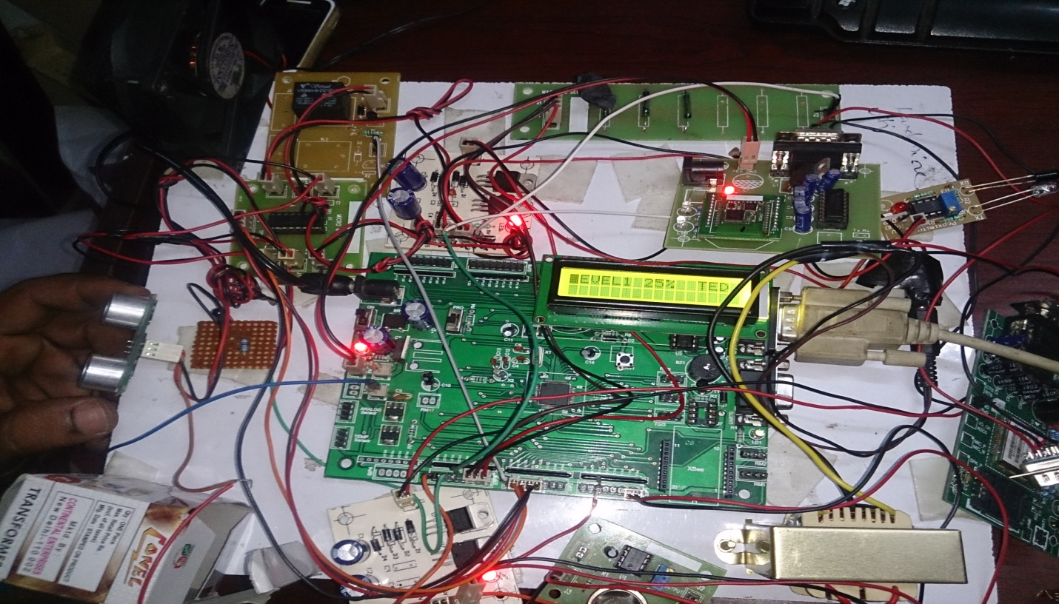

***Fig.5.2.9 Level 25% Detected LCD Display***

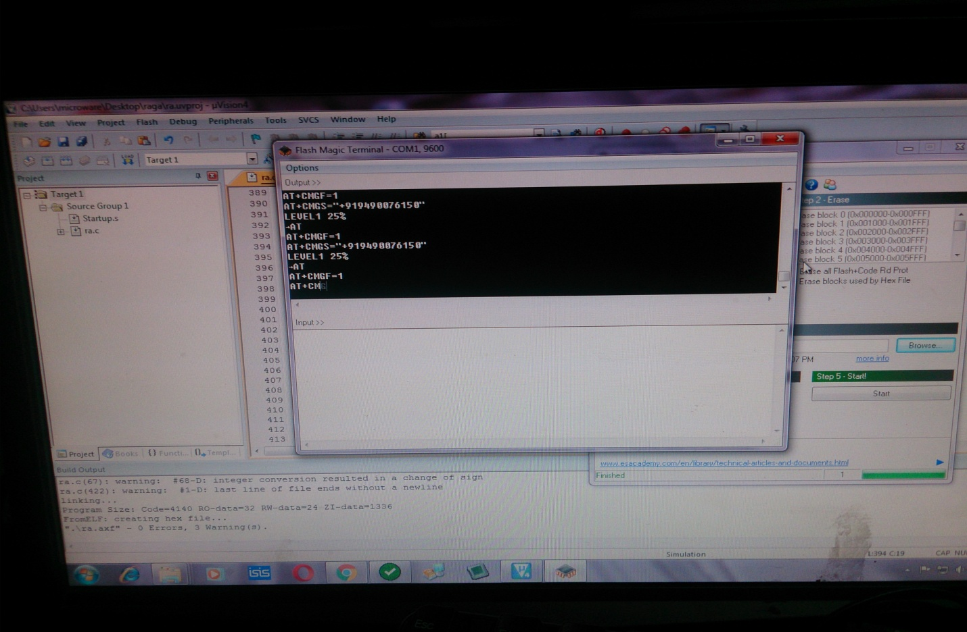

***Fig.5.2.10 Level Detected 25% System with AT Commands GSM***

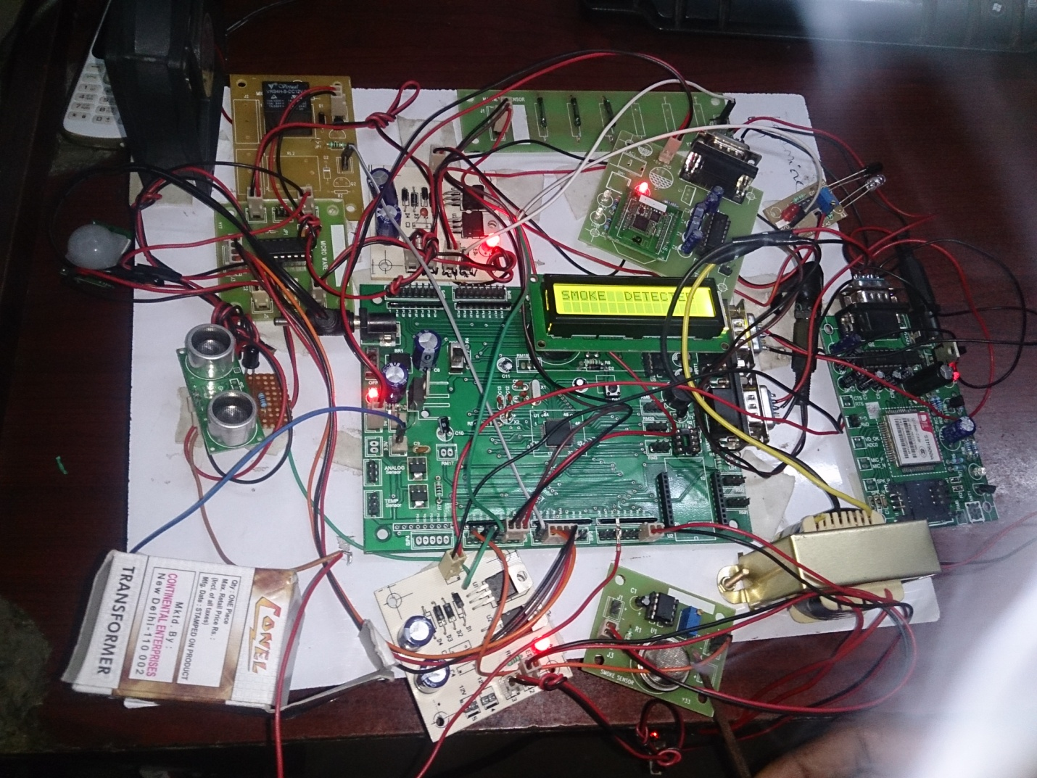

***Fig.5.2.11 Smoke Detected***

**5.3 ADVANTAGES**

* The proposed system is highly secured.
* It is used in real time applications.
* Its cost is less.
* It is reliable for long period of time.
* It can easily handle.
* It saves energy by activating and deactivating devices, When the device is idle stage.
* It is versatility. Which is to adapt many different situations.
* It is portability.

**5.4 UTILITIES AND APPLICATIONS**

* The proposed system increases the essential security and safety to our industry, homes and for other control applications .
* This system can also automatically controls the fan, light etc.
* Thus the system is fully automated and provides high level security and safety .
* This device increases the security and safety level in home, offices, military , industries etc.

**CONCLUSION**

The proposed system promotes the control engineer to obtain the data values anywhere and everywhere within the control room of an industry. This new system is suited for acquiring the control parameters like gas leakage, smoke detection, fire detection, obstacle detection and level process variables of an existing process controller. Sensors acquire the data and with help of LPC2148 Microcontroller- GSM module-ZigBee module the data values are transmitted to a mobile by SMS and monitored in PC also.

where parameter values are stored in memory while simultaneously the user can view and analyze the readings obtained in real time. Hence the proposed system behaves like a good user friendly device of the control engineer as the user can always be mobile anywhere and also it doesn’t require the person sitting in front of a panel display at all times monitoring the process. Here the process can be visualized in the screen of an ordinary mobile.

**FUTURE SCOPE**

The proposed system increases the usage of mobile technology and PC to provide essential security to our industry and for other control applications . This system can also automatically controls the fan, light etc. Thus the system is fully automated and provides high level safety and security . The proposed WSN system captures information and transmits it via a SMS through GSM module and PC through ZigBee module.

LPC2148 Microcontroller operates and controls motion detectors, fire detection, gas detection, obstacle detection and level detection for remote sensing and surveillance. For example , when motion is detected, The person detected text is displayed on LCD display and at the same time the text is forwarded to mobile with the help of GSM module and at the same time the text is displayed on PC. Similarly all the parameters are displayed on LCD display are send to mobile and PC.

**BIBLIOGRAPHY**

[1] A. I. Alexan, A. R. Osan and S. Oniga, “Assistme Robot, an assistance robotic platform,”

Carpathian Journal of Electronic and Computer Engineering 5 pp.1-4, 2012.

[2] Dataloggers (Last accessed Dec 2014) [Online]

<http://www.webopedia.com/TERM/D/data_logging.html>

[3] Design of Remote Intelligent Smart Home System Based on Zigbee and GSM

Technology <http://ijettjournal.org/volume-4/issue-9/IJETT-V4I9P144.pdf>

[4] Wang dong, Jinrong Zhang, Wei Yan, etc. using ZigBee technology to build wireless

sensor networks [J]. Chongqing University: Natural Science, 2006,29 (8) :95-98.

[5] OndrejS, ZdenekB,PetrF,OndrejH.ZigBeeTechnology and Device Design [ C].

Proceeding of the International Conference on Networking, International Conference on

Systems and International Conference on Mobile Communications and Learning

Technologies ,2006.

[6] Remote Monitoring and Controlling System based on ZigBee Networks

<http://www.ijoeet.com/pdf4/11.pdf>

[7] Wireless Sensor Networks for Industrial Applications

<http://www.issr-journals.org/ijias/>